Contents
POWER BI 3
POWER BI WORKFLOW 3
POWER BI BACKEND — POWER QUERY EDITOR 3
POWER BI FRONTEND 3
PUTTING THE ENTIRE POWER BI WORKFLOW TOGETHER 10
TYPES OF CONNECTORS 11
POWER QUERY EDITOR 11
STORAGE AND CONNECTION MODES 12
IMPORT MODE 13
DIRECTQUERY 13
LIVE CONNECTION 13
COMPOSITE MODEL 14
EXTRACTING DATA FROM WEB 15
DATA QA AND PROFILLING TOOL IN POWER QUERY EDITOR 16
COLUMN QUALITY 17
COLUMN DISTRIBUTION 18
COLUMN PROFILE 19
TEXT TOOLS 20
INDEX AND CONDITIONAL COLUMN 21
INDEX COLUMN 21
CONDITIONAL COLUMN 22
CALCULATED COLUMN BEST PRACTICES 23
GROUPING AND AGGREGATION 24
PIVOTING AND UNPIVOTING 25
MERGING AND APPENDING QUERIES 25
MERGE QUERIES 25
APPEND QUERIES 31
DATA-SOURCE SETTINGS 37
REFRESH QUERIES 38
CREATING DATA MODEL 39
NORMALIZATION 39
FACTS & DIMENSION 40
PRIMARY AND FOREIGN KEYS 40
CARDINALITY 40
FILTER FLOW 40
COMMON SCHEMA 40
HIERARCHIES 40

POWER BI
MS Power BI is a self service business intelligence platform, which includes both desktop and web based applications for connecting, modelling and visualizing data

POWER BI WORKFLOW
Power BI Desktop into two conceptual parts:
- Backend → Power Query Editor: prepares the data.
- Frontend → Model View + Data View + Report View: organizes the prepared data, performs analytics, and presents the results.
The overall flow is: Data Sources → Power Query Editor → Data Model → DAX/Calculations → Reports & Visuals
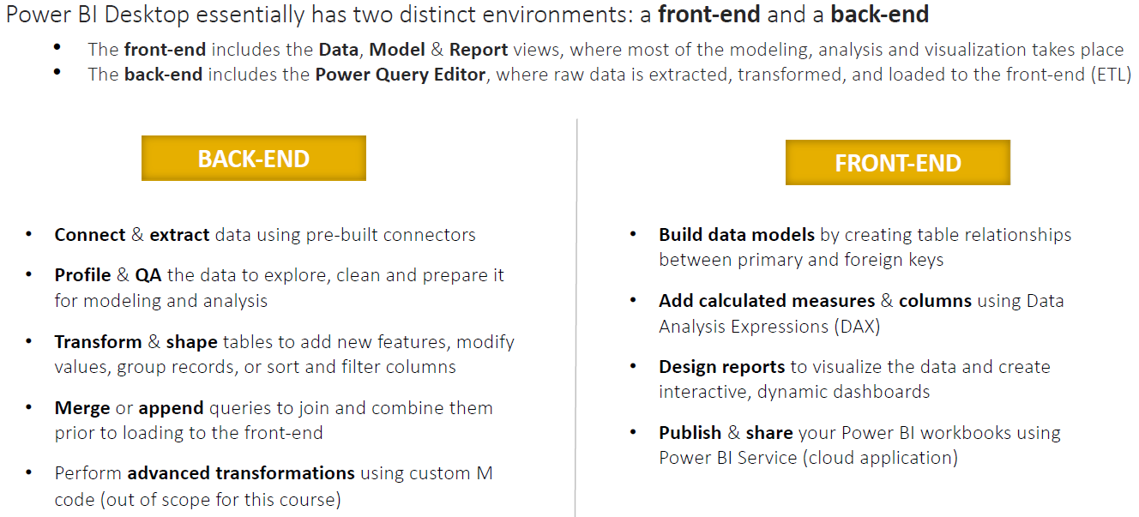

POWER BI BACKEND — POWER QUERY EDITOR
- The Power Query Editor is essentially the data preparation / ETL layer of Power BI.
- You connect Power BI to raw data sources such as Excel, CSV, SQL Server, SharePoint, APIs, databases, etc.
- Power Query then lets you extract, clean, transform, and combine that data before it enters the Power BI model.
- Typical Power Query operations include removing unnecessary columns, filtering rows, changing data types, handling null values, splitting or merging columns, pivoting/unpivoting data, joining tables, appending datasets, and creating transformation logic.
- For example, suppose your source contains:
Order Date | Customer | Product | Sales
01/01/26 | ABC | Laptop | 50000
02/01/26 | XYZ | Mouse | NULL
- In Power Query, you might correct the data types, replace or remove the null value, standardize product names, merge customer information from another table, and remove columns you don't need.
- The important idea is:
- Power Query answers: "How should I prepare and transform my raw data?"
- Power Query transformations are primarily written in the M language, although most users create them through the graphical interface.

POWER BI FRONTEND
- After Power Query has prepared the data, you primarily work with three views:Model View → Data View → Report View
- They have different responsibilities, although in practice you can move between them rather than following a rigid sequence.

IMPORTANT TERMINOLOGIES
EXAMPLE: A SUPERMARKET SALES DASHBOARD.
Suppose a supermarket wants to analyze:
- How much did we sell?
- Which products sold the most?
- Which city generated the most revenue?
- What were monthly sales?
To answer these questions in Power BI, we build a semantic model containing fact tables, dimension tables, relationships, and measures.

FACT TABLE
A fact table contains the business transactions/events you want to analyze.
Suppose our supermarket has this Sales table:
Date | ProductID | CustomerID | Quantity | SalesAmount
1-Jan | P01 | C01 | 2 | ₹200
1-Jan | P02 | C02 | 1 | ₹500
2-Jan | P01 | C03 | 3 | ₹300
2-Jan | P03 | C01 | 1 | ₹1,000
- Each row represents a sale.
- This is a fact table because it records the event we're analyzing and contains numeric values such as: Quantity, Sales Amount, Cost, Profit, Discount, etc.
- A simple definition is: Fact table = table containing business transactions/events and the numbers we want to analyze.

DIMENSION TABLE
- A dimension table contains descriptive information about the facts.
- For example, our Sales table only says P01, P02, etc. We need another table to explain what those products actually are.
- Product Dimension
ProductID | ProductName | Category | Brand
P01 | Milk | Dairy | Amul
P02 | Rice | Grocery | India Gate
P03 | Mixer | Appliance | Philips
- We could also have a Customer dimension:
CustomerID | CustomerName | City
C01 | Rahul | Delhi
C02 | Priya | Mumbai
C03 | Amit | Kolkata
- And a Date dimension:
Date | Month | Quarter | Year
1-Jan-26 | January | Q1 | 2026
2-Jan-26 | January | Q1 | 2026
- These tables don't primarily record sales transactions. They describe the sale.
- Dimension table = table containing descriptive information used to categorize, filter, and group facts.
- For example, if the manager asks: "Show me Sales by Product Category by Month."
- Then:
  - Sales → Fact table
  - Product Category → Product dimension
  - Month → Date dimension

FACT + DIMENSION = STAR SCHEMA

In Power BI's Model View, we'd connect those tables:  - Because the diagram resembles a star, this design is called a Star Schema.  - The easiest memory trick is:  - Fact = What happened? Ex. A sale of ₹500 happened.  - Dimension = Who/What/Where/When? Ex. Who bought it? What product? Which city? What date? | 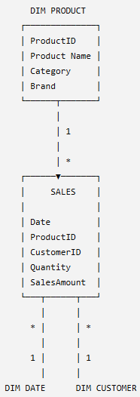

MEASURE
- A measure is a calculation that Power BI performs on your data, usually written using DAX.
For example, we have this column in our Sales fact table:
SalesAmount | - We can create: Total Sales =  SUM(Sales[SalesAmount])  - Power BI calculates: ₹200 + ₹500 + ₹300 + ₹1,000 = ₹2,000  - Measure = a dynamic calculation used to calculate business metrics/KPIs.
₹200
₹500
₹300
₹1,000
Other measures could be:  Total Quantity =  SUM(Sales[Quantity]) | Total Profit =  SUM(Sales[Profit]) | Profit Margin % =  DIVIDE(  [Total Profit],  [Total Sales]  )
- Suppose: Total Sales = ₹2,000
- Then the user selects Delhi from a slicer Power BI might automatically recalculate Delhi Total Sales = ₹1,200 Then the user selects January Delhi + January Total Sales = ₹800
- The DAX formula hasn't changed. The filter context changed, so the measure recalculated.

SEMANTIC MODEL
- A semantic model is the organized business-ready data model that Power BI uses for analysis and reporting.
- It contains things such as:
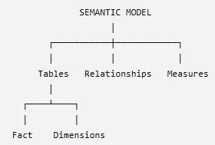 | Considering Super Market example  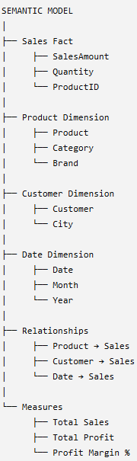
- The semantic model sits between your prepared data and your report visuals.
- For example, the report developer doesn't need to repeatedly figure out how to calculate sales. They can simply use the existing measure: [Total Sales] in a Card, Bar Chart, Matrix, etc.
- Semantic model = tables + relationships + calculations + business meaning, organized so that Power BI can analyze the data correctly.

PUTTING ALL 4 TOGETHER
Imagine the manager asks:"What were total sales by product category in January?"
Power BI uses all four concepts:
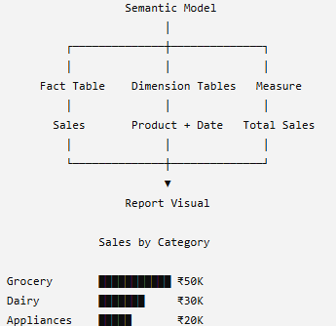

So remember these four definitions:
Term | Simple meaning | Example
Fact Table | What happened? | Sales transactions
Dimension Table | Describes what happened | Product, Customer, Date
Measure | What do I want to calculate? | Total Sales, Profit, Margin %
Semantic Model | Everything organized together for analysis | Facts + Dimensions + Relationships + Measures

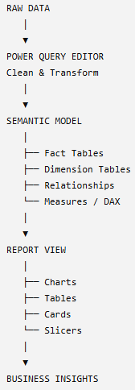 | This distinction—Power Query prepares the data, the semantic model gives the data analytical/business structure, and Report View presents the results.

MODEL VIEW — BUILD THE DATA MODEL
- The Model View defines how your tables relate to one another.
Suppose Power Query loads four tables:  Sales  DateKey ProductKey CustomerKey Sales  20260101 P101 C001 50,000  Products  ProductKey Product  P101 Laptop  Customers  CustomerKey Customer  C001 ABC Ltd  Calendar  DateKey Date Month Year  20260101 1-Jan-26 Jan 2026 | In Model View, you establish relationships such as:  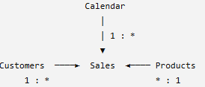
- Here, Sales is the fact table, while Customers, Products, and Calendar are dimension tables.
- In Model View you typically manage relationships, cardinality (1:*, 1:1, etc.), cross-filter direction, active/inactive relationships, table organization, and properties related to the semantic model.
- Model View answers: "How are my tables connected and how should the data model behave?"

DATA VIEW — UNDERSTAND DATA AND CREATE CALCULATIONS
- The Data View lets you inspect the data that has been loaded into the model in a table-like format.
- This is also where you can work with model-level calculations such as calculated columns and calculated tables.
- Measures can also be created while working in Power BI Desktop; they belong to the semantic model rather than being conceptually tied only to Data View.
- This is where DAX (Data Analysis Expressions) becomes important. For example, you could create measures such as:

Total Sales =  SUM(Sales[Sales]) | Total Profit =  SUM(Sales[Profit]) | Profit Margin % =  DIVIDE(  [Total Profit],  [Total Sales]  )
You might also create a calculated column:
Full Name =
Customer[First Name] & " " & Customer[Last Name]

The distinction between Power Query/M and DAX is especially important:
Power Query | DAX
Data preparation | Data analysis
Before/while loading data | After data is loaded into the model
Uses M language | Uses DAX language
Clean/transform data | Measures/calculated columns/tables
Merge, append, filter, reshape | SUM, CALCULATE, DIVIDE, time intelligence, etc.
- Data View helps answer: "What data is in my model, and what analytical calculations do I need?"

REPORT VIEW — BUILD THE DASHBOARD/REPORT
- Finally, the Report View is where you create what the end user actually sees.
- You take the model and measures created in the previous stages and turn them into visualizations such as bar charts, line charts, tables, matrices, cards/KPIs, maps, slicers, decomposition trees, and other interactive visuals.
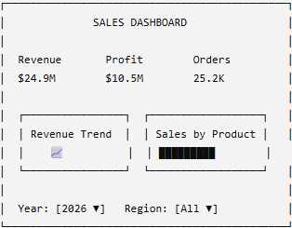 | For example, after creating:  - Total Revenue = SUM(Sales[Revenue])  - We could place [Total Revenue] into a Card visual.  - Then combine that with other visuals:  The Report View therefore handles the presentation and interaction layer: visuals, formatting, filters, slicers, drill-through, tooltips, bookmarks, navigation, and report pages.  So:

PUTTING THE ENTIRE POWER BI WORKFLOW TOGETHER
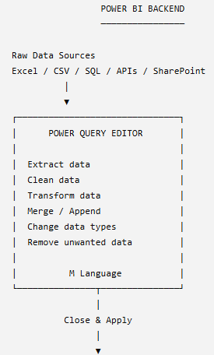
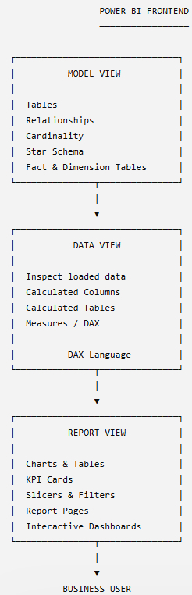

Component | Main purpose | Think of it as
Power Query Editor | Clean & transform raw data | Data preparation
Model View | Connect and organize tables | Data architecture
Data View | Inspect data & create calculations | Data analysis / DAX
Report View | Build visuals and reports | Data presentation
- Power BI starts with the Power Query Editor, which acts as the backend data-preparation layer where we connect to data sources and perform ETL transformations using Power Query/M.
- Once the data is loaded, the frontend consists of the Model View, where we define relationships and the semantic model;
- The Data View, where we inspect the loaded data and create DAX-based calculations;
- The Report View, where we use that model and those measures to build interactive reports and visualizations.

TYPES OF CONNECTORS
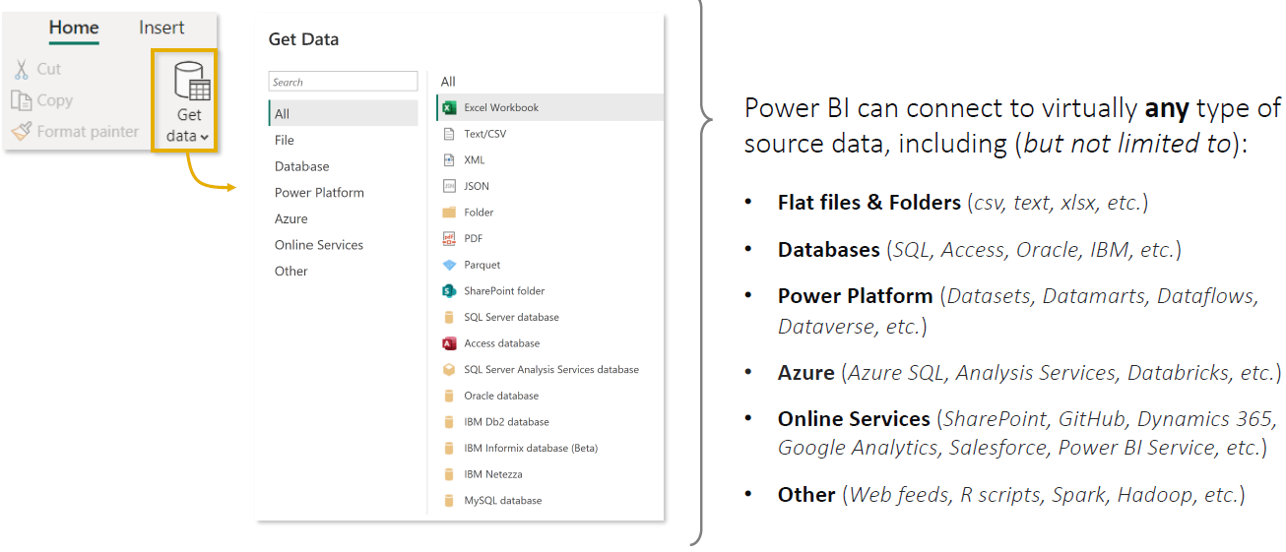
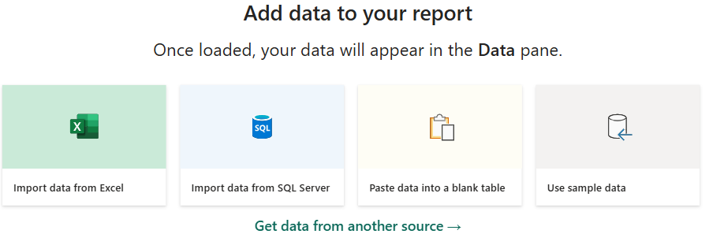

POWER QUERY EDITOR

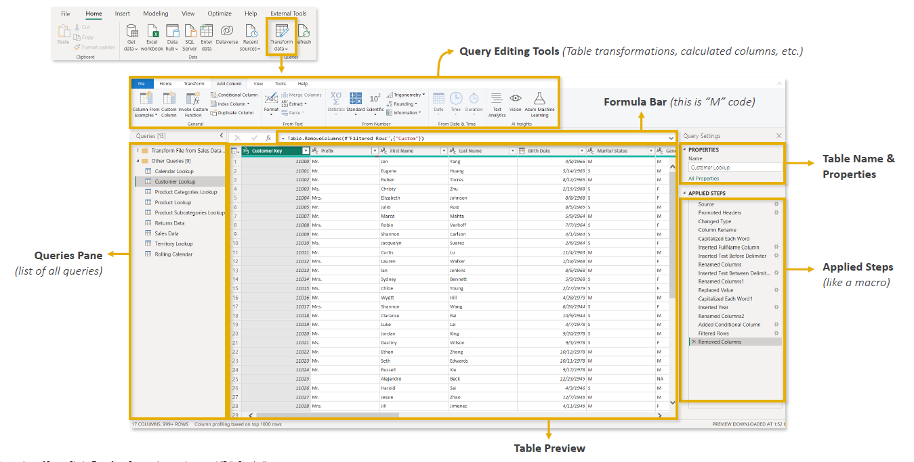

- Power Query Editor is the main workspace in Power BI for connecting, cleaning, transforming, and preparing data before it is loaded into reports.

KEY COMPONENTS OF THE POWER QUERY EDITOR
- Query Editing Tools (Top Ribbon)
- Contains tools for shaping and transforming data.
- Includes options to clean, filter, merge, split, and modify data.
- Formula Bar
- Displays M Code, the language used by Power Query.
- M Code is automatically generated when you perform transformations.
- Queries Pane (Left Side)
- Lists all data queries/connections.
- Allows you to select, view, edit, and manage queries.
- Each query represents a dataset or table.
- Data Preview (Center)
- Shows a preview of the selected query.
- Used for validating data, changing column types, renaming columns, and checking transformations.
- Properties Pane (Right Side)
- Displays query properties, especially the table name.
- Applied Steps Pane
- Records every transformation as a step.
- These steps are automatically replayed whenever data is refreshed.

STORAGE AND CONNECTION MODES
- In Power BI, storage/connection mode tells Power BI where the data lives and how Power BI retrieves it when a user interacts with a report.
- The main modes to understand are
  - Import
  - DirectQuery
  - Direct Lake
  - Live Connection as a related connection approach.
  - Composite Model, where different tables can use different modes.

IMPORT MODE
- In Import mode, Power BI connects to the source, retrieves the data, and loads a compressed copy into the Power BI semantic model.
- The dataset must be in less than 1GB after compression
- The tables are stored in memory with Power BI and queries are fulfilled by cached data
- Import datasets are useful when we need fast query performance.
- Useful when source data does not changes frequently
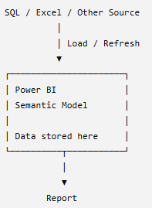 | Suppose SQL Server contains:  Product Sales  Laptop ₹50,000  Mobile ₹30,000  TV ₹40,000  - Power BI imports a copy of those records.  - When you create: Total Sales =  SUM(Sales[Sales])  - Power BI calculates against the imported data, rather than sending a SQL query back to the source every time you click a visual.  - That's why Import mode is generally very fast for report interaction.  - However, imagine someone inserts another ₹10,000 sale into the SQL database at 2 PM.  - Power BI won't automatically know about it just because the source changed. The imported model needs to be refreshed to bring in the latest source data.  - Import = Bring the data into Power BI → very fast analysis → refresh required for source changes

DIRECTQUERY
With DirectQuery, Power BI generally does not import the full table data into the semantic model.
Instead, the data remains in the underlying source.
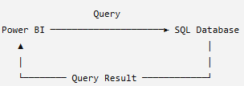 | - Directly connects Power BI to the source data without importing the entire dataset into Power BI.  - Queries are sent to the source system and executed on demand whenever data is required.  - Commonly used when:  - The dataset is too large to efficiently import and store in memory.  - Source data changes frequently and reports need access to up-to-date data.  - For example – Use case when Company/security policies cannot be importing or copying data into Power BI.  - Data must remain in and be accessed from the original source system.  - Key idea:  Data stays at the source → Power BI sends queries to the source → Source processes the query → Results are returned to Power BI.

LIVE CONNECTION

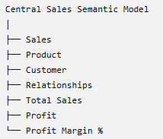 | - Imagine another team has already created a centralized Power BI semantic model:  - You don't necessarily want to recreate everything.  - Instead, your Power BI report can connect to that existing semantic model.  - The report uses the centralized model's tables, relationships, measures, and security/business logic.  - This is useful in enterprise environments because many reports can reuse the same governed semantic model.  - Example  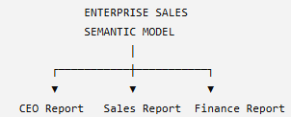
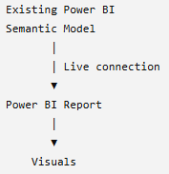

Instead of each report developer independently recreating:
Total Revenue
Total Profit
Profit Margin
the organization can define these measures centrally.
So:
Live connection = Build a report on an existing Analysis Services/Power BI semantic model rather than creating an independent imported model from the original raw source.
Modern Power BI also supports extending some connections to existing Power BI semantic models through composite-model capabilities, so "live connection" shouldn't be treated as meaning that the report can never have local modeling. q

COMPOSITE MODEL
- You don't necessarily have to choose one mode for everything.
- A semantic model can combine storage approaches.
For example:
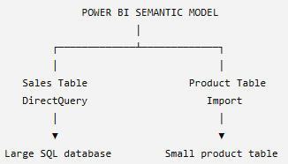
Suppose:
- Sales = 500 million rows and changes frequently
- Product = 10,000 rows and changes rarely
You might keep Sales in DirectQuery, while importing Product for faster access.
This creates a Composite Model.
Composite Model = A semantic model that combines different storage/connection approaches.

EXTRACTING DATA FROM WEB
- The Web Connector allows Power BI to retrieve data from websites and web-hosted files(csv,xlsx etc.).
- Power BI can scan a webpage, identify structured tables, and make them available for import.
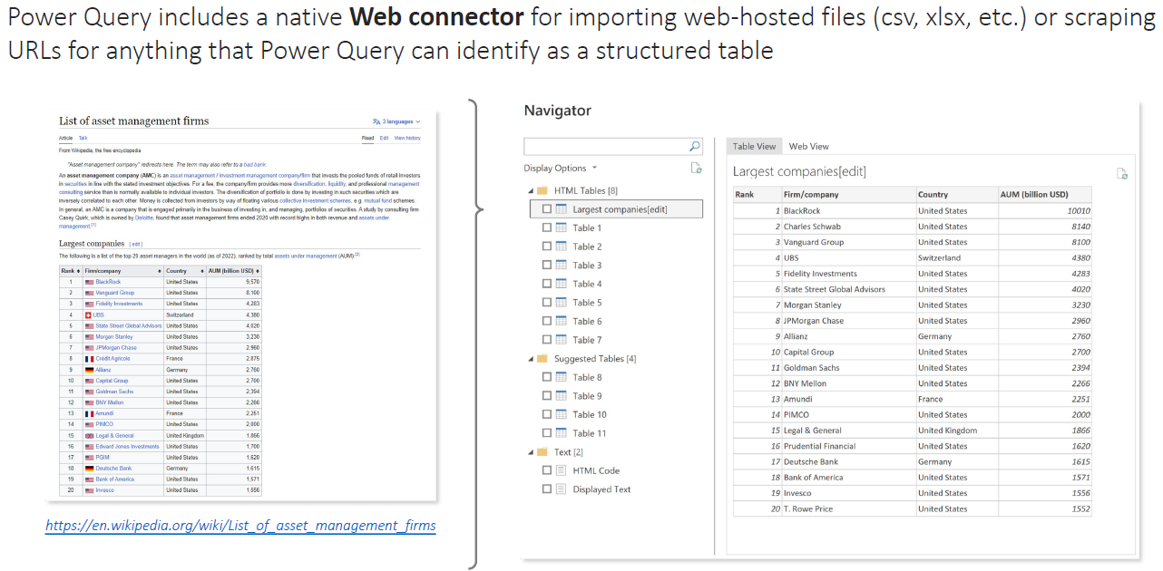
Website to scrap : https://en.wikipedia.org/wiki/List_of_asset_management_firms
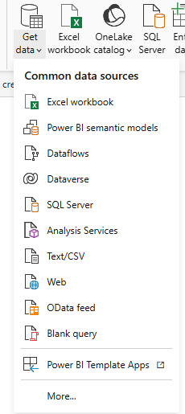 | 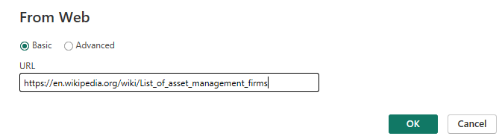  - To connect to a webpage:  - Go to New Source → Web.  - Copy and paste the webpage URL.  - Choose Basic connection and click OK.  DATA PREVIEW  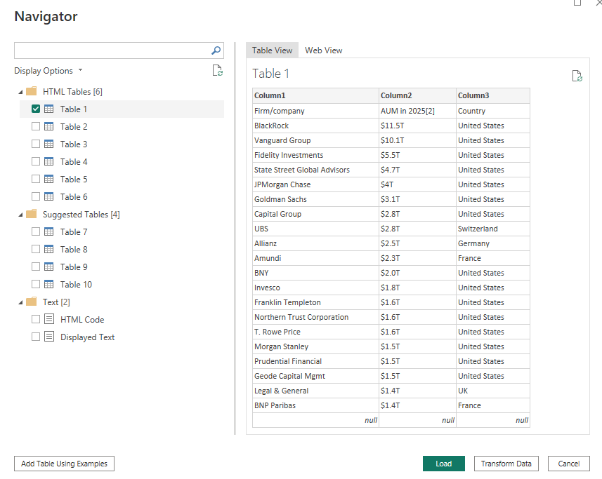
- After connecting, Power BI opens the Navigator/Data Preview window.
- Power BI displays the different tables/elements detected on the webpage.
- Selecting a table shows a preview of its data.
- Web View lets you view the actual webpage, making it easier to identify which webpage table corresponds to the detected table.
- You can select the required table(s) and load/transform them in Power Query Editor.
- Once in Power Query, the data can be cleaned and transformed like any other data source:
  - Check and correct column headers.
  - Verify data types such as Text, Whole Number, and Currency.
  - Apply additional transformations if required.
  - Give the query a meaningful name.
- Key takeaway: Webpage URL → Web Connector → Detect Tables → Preview/Select Table → Power Query → Clean & Transform → Load Data.

DATA QA AND PROFILLING TOOL IN POWER QUERY EDITOR
- Data profiling means examining your data before using it in your Power BI model/report to understand its quality, structure, and potential problems.(Think of it as a health check for your data.)
- Suppose Power Query contains this customer data:
Row Customer Age City  1 Amit 25 Delhi  2 Priya 32 Mumbai  3 Rahul 25 Delhi  4 Neha 40 Kolkata  5 Arjun 25 Delhi  6 Riya Error Mumbai  7 Karan 32  8 Pooja 28 Delhi  9 Sameer 35 Mumbai  10 Anjali 30 Delhi | Before loading this data, we want to know:  - Are there errors?  - Are there blank/null values?  - How many different values exist?  - Are there unexpected duplicates?  - What are the minimum and maximum values?  - Which values occur most frequently?

Power Query provides three main profiling tools for this:
- Column Quality
- Column Distribution
- Column Profile

COLUMN QUALITY
- Column Quality tells you whether the values in a column are Valid, Error, or Empty.
- It displays these as percentages.
- Imagine you have 1 million records.You don't want to manually scroll through one million rows looking for problems.
- For example, look at our Age column:There are 10 records:
- 9 valid
- 1 error
- 0 empty
Column Quality would therefore show approximately:
AGE
Valid 90%
Error 10%
Empty 0%
The three categories
Category | Meaning
Valid | Value is acceptable for the column's data type
Error | Power Query encountered an error for that value
Empty | Value is null/missing
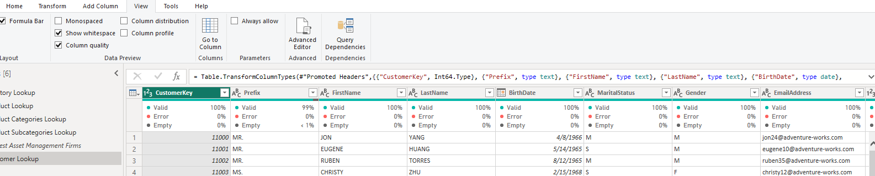
- Note – initially the profile shows the report based on top 1000 records, to update and get column quality profile data

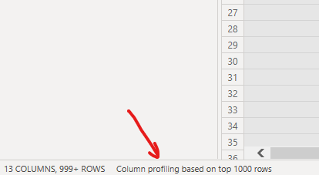

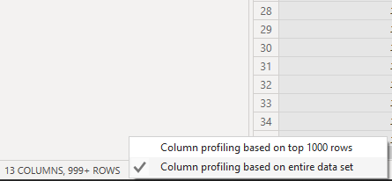
To clean up the column we can use the options from context menu of the column
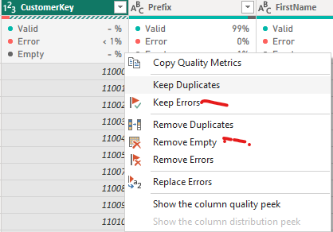

COLUMN DISTRIBUTION
- Column Distribution answers a different question:"How are the values in this column distributed?"
- It shows information such as:
- Distinct values
- Unique values
- Frequency/distribution of values
This introduces two important terms.
DISTINCT VS UNIQUE
- Distinct = number of different values.
Unique = number of values that occur exactly once.
Suppose the City column contains:  - Delhi  - Mumbai  - Delhi  - Kolkata  - Delhi  - Mumbai  - Chennai  Distinct values means - Different values that exist:  - Delhi  - Mumbai  - Kolkata  - Chennai  Distinct = 4  Even though Delhi appears three times, it is counted only once | Unique values : Values that appear exactly once:  - Kolkata → appears once  - Chennai → appears once  Therefore: Unique = 2

Another example  Suppose:  Age  ---  25  25  25  32  32  28  35  40 | The distribution is:  Age Frequency  25 3  32 2  28 1  35 1  40 1 | Distinct = 5  Unique = 3  because only:  The visual distribution might look roughly like:  25 ███████████████ 3  32 ██████████ 2  28 █████ 1  35 █████ 1  40 █████ 1
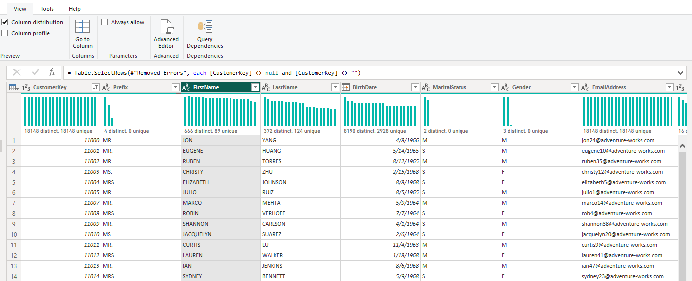

COLUMN PROFILE
- Column Profile is the most detailed of the three tools.
- It provides a more complete analysis of a selected column. It is detailed report card for one column.
- It combines information about the column with additional statistics.
- For example, select the Age column.
Power Query could show:  Column Statistics  Count 10 Total number of values/records considered in the column.  Error 1 Number of error values.  Empty 0 Number of missing/null values.  Distinct 7  Unique 5  Min 25  Max 40 | the Value Distribution:  25 ███████████  32 ███████  28 ███  30 ███  35 ███  40 ███
- Data Profiling → Find the problem → Understand the problem → Apply Power Query transformation → Clean data
- Column Quality → "Do I have problems?"
- Column Distribution → "What does my data look like?"
- Column Profile → "Give me detailed information about this column."

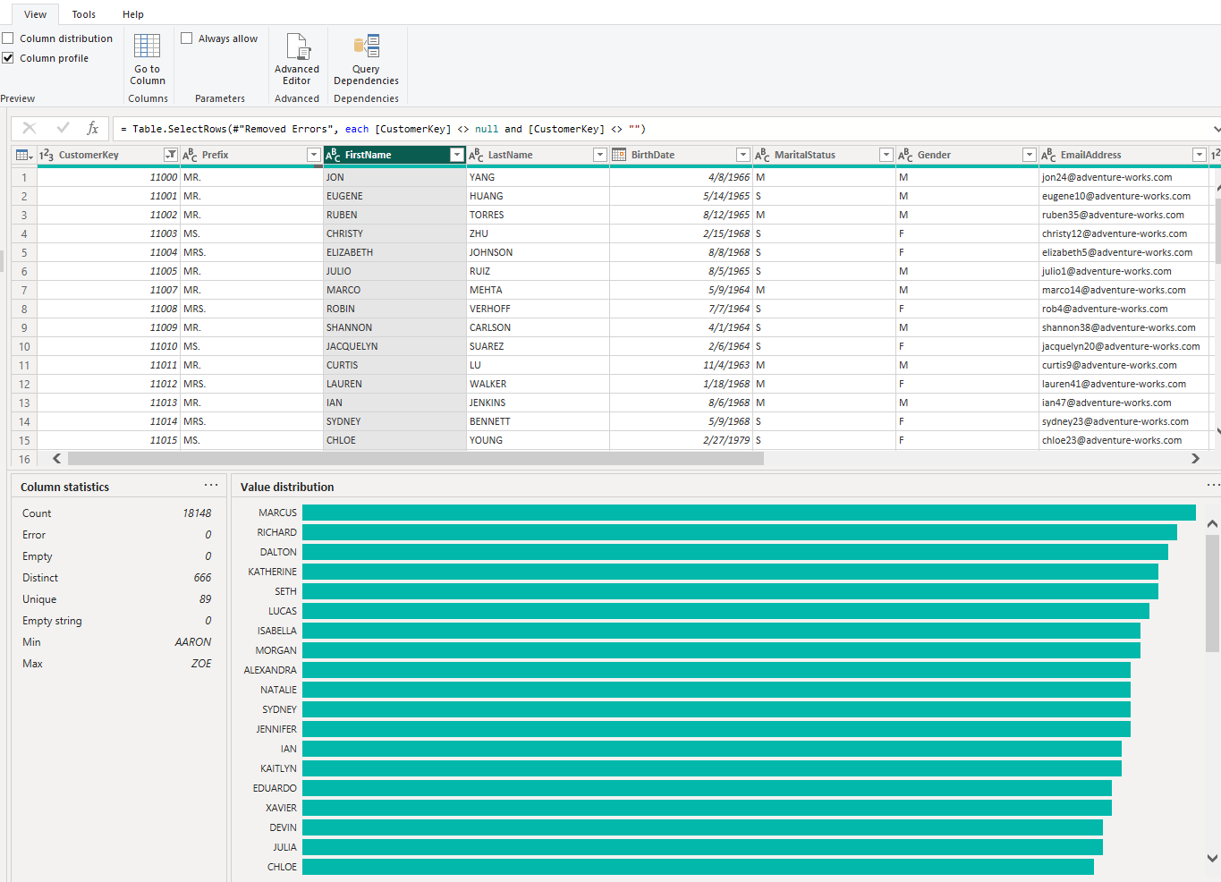

TEXT TOOLS
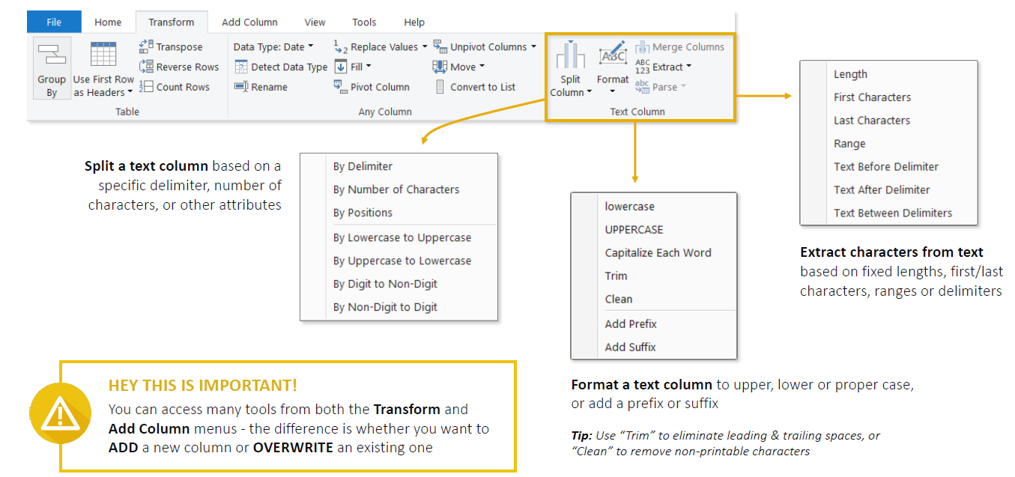
- Text-specific tools are available in the Power Query Editor, mainly under the Transform and Add Column tabs.
- They are used to clean, format, split, combine, and extract information from text columns.
Split Column  - Used to divide one text column into multiple columns.  - A column can be split based on:  - A delimiter such as -, ,, /, or space.  - A specific number of characters. | Example:  CustomerID = INDIA-10025  Split using -: “-” delimiter  Country ID  INDIA 10025
3. Format Text  Power Query provides several formatting options:  - lowercase: NEW YORK → new york  - UPPERCASE: india → INDIA  - Capitalize Each Word / Proper Case: john smith → John Smith  - Trim: removes leading and trailing spaces.  - Clean: removes non-printable/control characters. | Trim is especially important. For example:  "India"  "India "  They look identical to us, but the second value contains a trailing space. Power BI may therefore treat them as two different values.  Using Trim standardizes them:  "India"  "India "  ↓  "India"  "India"
Extract Tools  Extract allows you to take only a particular part of a text string.  You can extract:  - First characters  - Last characters  - A specific range of characters  - Text before a delimiter  - Text after a delimiter  - Text between delimiters | For example:  EmployeeID = INDIA-MUMBAI-10025  Before delimiter -:INDIA  After a chosen delimiter:MUMBAI-10025  Between delimiters:MUMBAI  Advanced options also let you control things such as whether Power Query searches from the start or end of the string and which occurrence of a delimiter should be used.
Merge Columns  - Merge Columns combines multiple columns into one.  - You need to select multiple columns before this option becomes available. | For example:  First Name Last Name  Rahul Sharma  Merge with a space: Rahul Sharma

DATE AND TIME TOOL
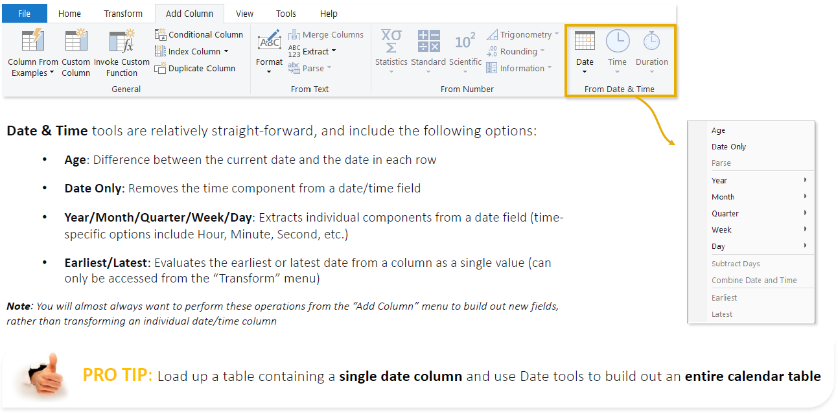

INDEX AND CONDITIONAL COLUMN
Both are available in Power Query Editor → Add Column, but they serve very different purposes.

INDEX COLUMN

An Index Column adds a sequential number to each row(Think of it as adding a row number) | Suppose your data is:  Product Sales  Laptop 50,000  Mobile 30,000  TV 40,000 | After adding an Index:  Index Product Sales  1 Laptop 50,000  2 Mobile 30,000  3 TV 40,000

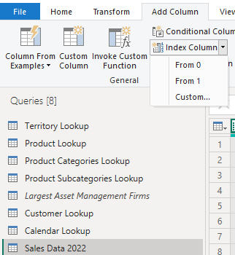 | How to add it  Go to:Power Query Editor → Add Column → Index Column  You can choose:  - From 0 → 0, 1, 2, 3...  - From 1 → 1, 2, 3, 4...  - Custom → choose your own starting number and increment.  For example, custom settings:  Start = 100, Increment = 10  produces:  100, 110, 120, 130...  Why use an Index Column?  It is useful for:  - Adding row numbers  - Creating a simple sequential identifier  - Preserving/working with a particular row order  - Supporting transformations that need previous/next-row logic  - Creating ranking-like sequences after sorting data  Index Column = Give each row a sequential number.

CONDITIONAL COLUMN
- A Conditional Column creates a new column based on IF/THEN logic. IF this condition is true → return this value; otherwise → return another value.
- Example:
Employee Sales  Amit 120,000  Rahul 75,000  Priya 40,000 | We want a new column:  - Sales ≥ 100,000 → High  - Sales ≥ 50,000 → Medium  - Otherwise → Low | After adding a Conditional Column:  Employee Sales Sales Category  Amit 120,000 High  Rahul 75,000 Medium  Priya 40,000 Low
How to create it
Go to:Power Query Editor → Add Column → Conditional Column
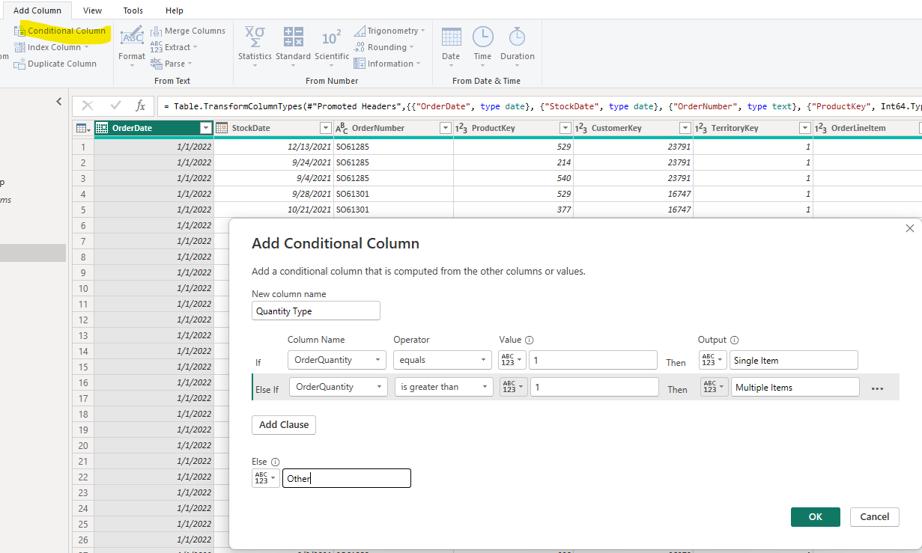

CALCULATED COLUMN BEST PRACTICES

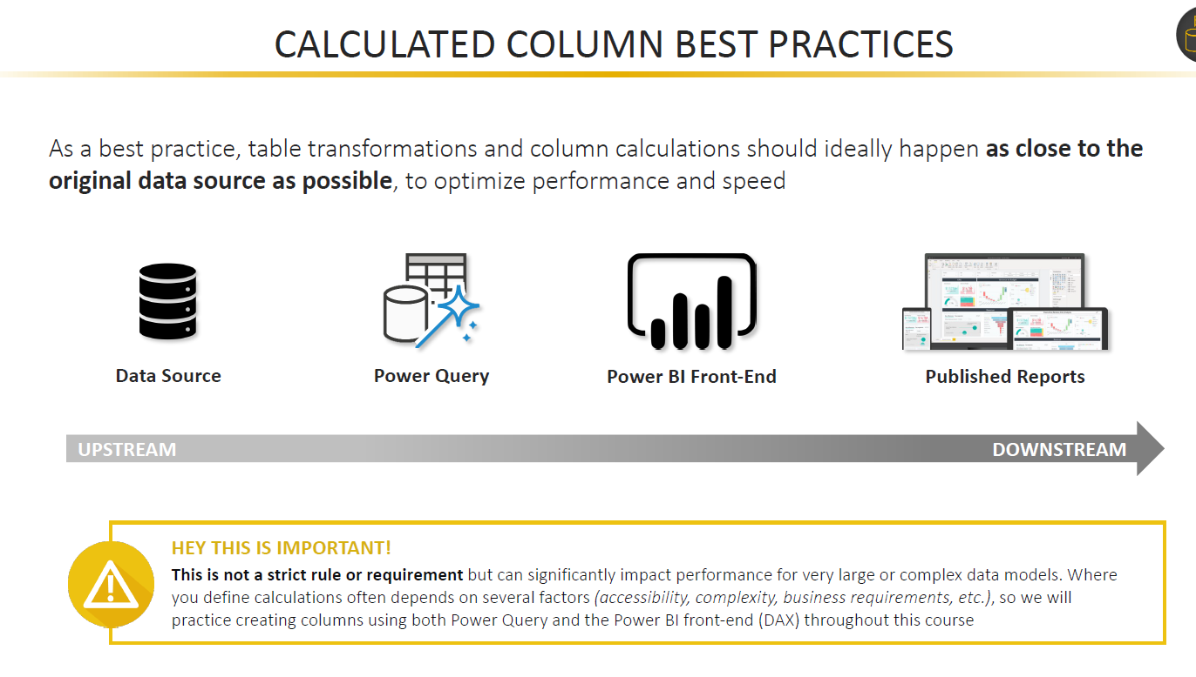
- Think about calculated column best practices as deciding where the work should be done.
- Suppose your company has employee data:
First Name | Last Name | Salary
Rahul | Sharma | 50,000
Priya | Singh | 70,000
- You want to create a new column:Full Name = First Name + Last Name
There are several places where you could create it.
Option 1 — Create it in the Data Source ⭐ Best if practical
- If the data comes from SQL Server, you could ask SQL Server to provide:
First Name | Last Name | Full Name | Salary
Rahul | Sharma | Rahul Sharma | 50,000
Priya | Singh | Priya Singh | 70,000
- Now Power BI doesn't have to create Full Name. It simply receives it.
- Think of it like ordering food from a restaurant:
- It's better if the kitchen prepares the food before sending it to your table, rather than giving you ingredients and asking you to prepare it yourself.
- The database is designed to process data, so if the transformation can sensibly happen there, let the source do the work.

Option 2 — Create it in Power Query ⭐ Next choice
- Sometimes you cannot modify the source database.
- Maybe you don't have permission to change SQL or the source is an Excel file you don't control.
- Then use Power Query:
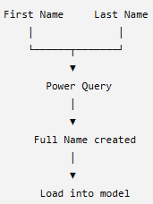
Power Query prepares the column before the final data is loaded into the Power BI model.
This is why Power Query is an excellent place for things like:
- Combining columns
- Splitting columns
- Cleaning text
- Replacing values
- Conditional columns
- Removing unnecessary columns
- Other row-by-row data preparation

Option 3 — Create a DAX Calculated Column in Power BI
You can also load the original data first and then create:
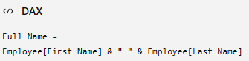
This works perfectly.But now the new column is being created inside the Power BI semantic model.
Why does this matter from performance prespective?
- Power BI Import mode uses an engine called VertiPaq.
- VertiPaq takes your data and tries to compress and organize it efficiently in memory so your reports can run quickly.
- Imagine you're loading: 50 million sales records, If you unnecessarily create lots of additional calculated columns inside the model, those columns also have to be stored and can make the model larger.
For example:
Original Model(500 MB) + Several unnecessary calculated columns Larger modelMore memory usagePotentially slower / less efficient

GROUPING AND AGGREGATION
GROUP BY – BASIC
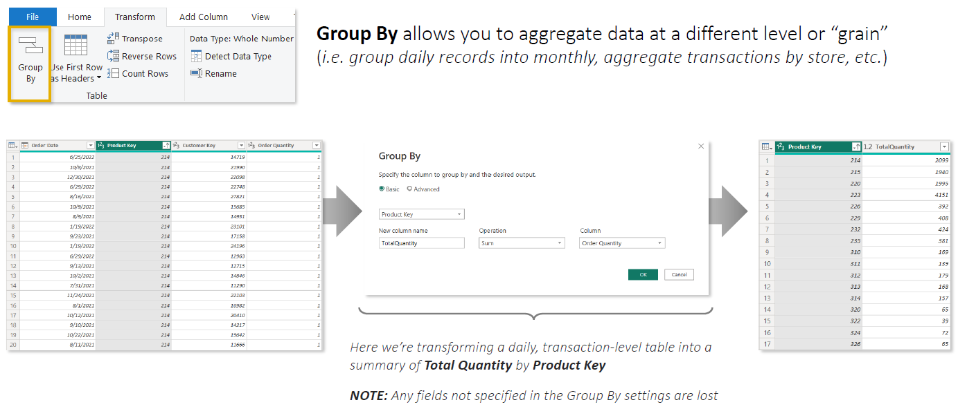
GROUP BY – ADVANCED
- The advanced option give a flexibility to group by multiple columns
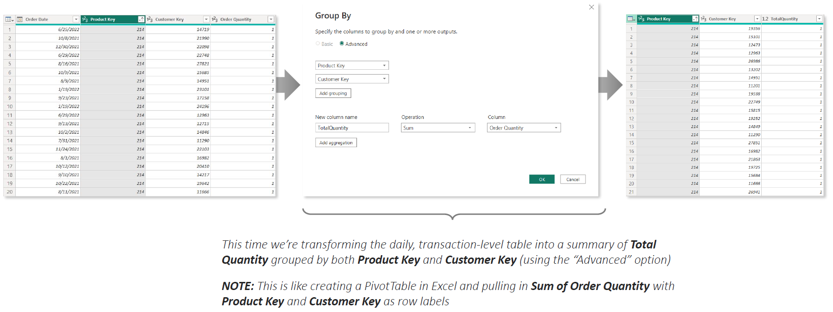

PIVOTING AND UNPIVOTING

MERGING AND APPENDING QUERIES
- Both Merge and Append are used in Power Query Editor to combine data from multiple tables, but they combine data in completely different ways.
- Merge = Add COLUMNS → combine side by side
- Append = Add ROWS → stack one table below another

MERGE QUERIES
Merge Queries combines two tables horizontally by matching a common column/key.
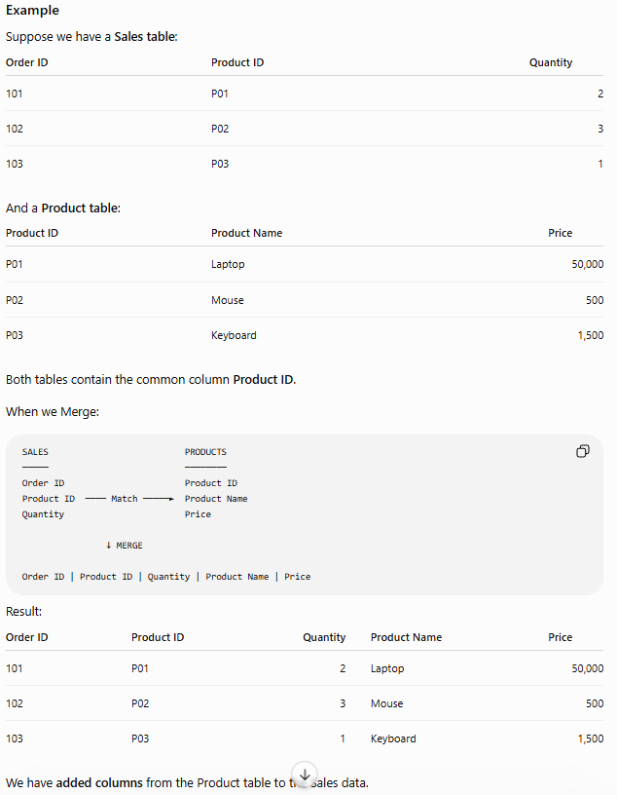
How to do it
Power Query Editor → Home → Merge Queries
Then:
- Select the first table.
- Select the second table.
- Select the matching column(s).
- Choose the Join Type.
- Click OK.
- Expand the resulting column to select the fields you want.
Common Join Types
Join | Meaning
Left Outer | All rows from first table + matching rows from second
Right Outer | All rows from second + matching rows from first
Inner | Only rows that match in both
Full Outer | All rows from both tables
Left Anti | Rows in first table that don't exist in second
Right Anti | Rows in second table that don't exist in first
Left Outer is one of the most commonly used.
Merge Queries vs Merge Queries as New
Exactly. The difference is simply where the merged result goes.
MERGE QUERIES
- Performs the merge inside the currently selected query.
- It does not create a separate merged query.
- Your other/source query remains available.
- After the merge, you can expand the matched columns into your current table.
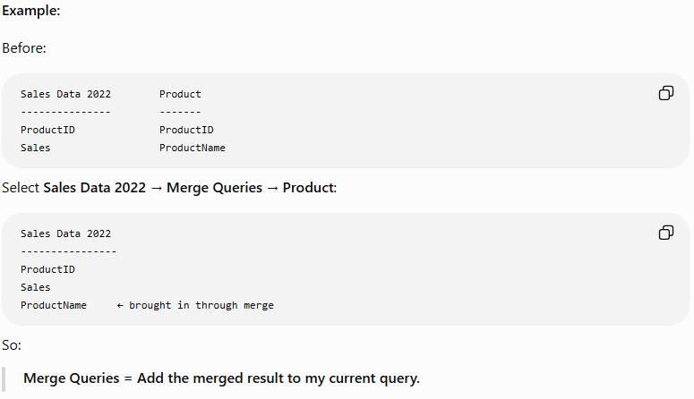
MERGE QUERIES AS NEW
- Leaves both original queries unchanged.
- Creates a third, new query containing the merged result.
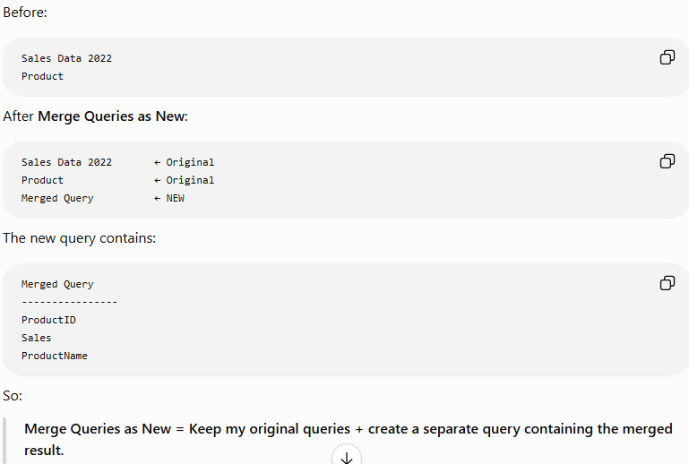
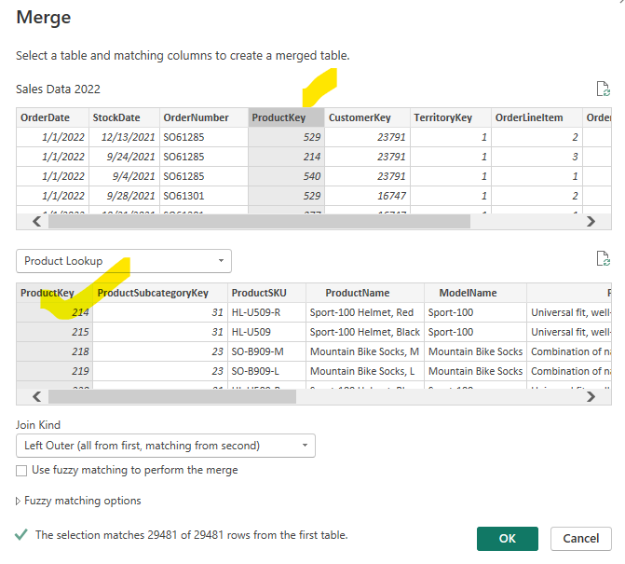

- Select the main table: Example: Sales Data 2022.
- Go to Home → Merge Queries.
- Select the second table: Example: Product Lookup.
- Select the common/key column in both tables.
  - Sales[Product Key] ↔ Product Lookup[Product Key].
- Choose the Join Type: Usually Left Outer: keep all Sales rows and bring matching Product information.
- Click OK.
- A new Table column appears in the Sales table.
- Click the Expand (⇔) button on that column.
- Select only the columns you need, e.g.:
  - Product Name
  - Product Color
- Click OK → the selected columns are added to the Sales table.
Result:
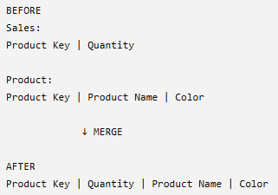
Key Points
- Merge = adds COLUMNS, not rows.
- Don't merge just because you can. In Power BI models, keeping Fact and Dimension tables separate and creating relationships is often preferable because unnecessary merges can create duplicated/redundant data.
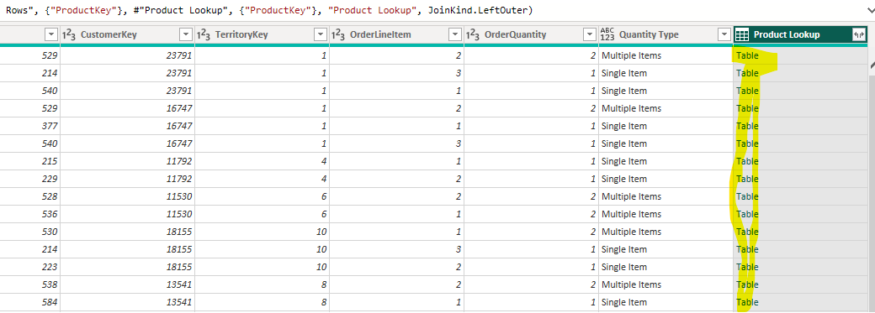

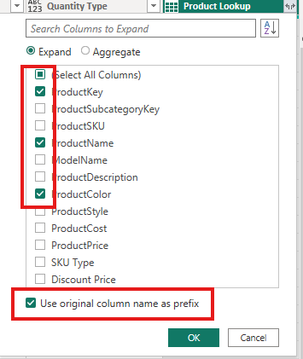
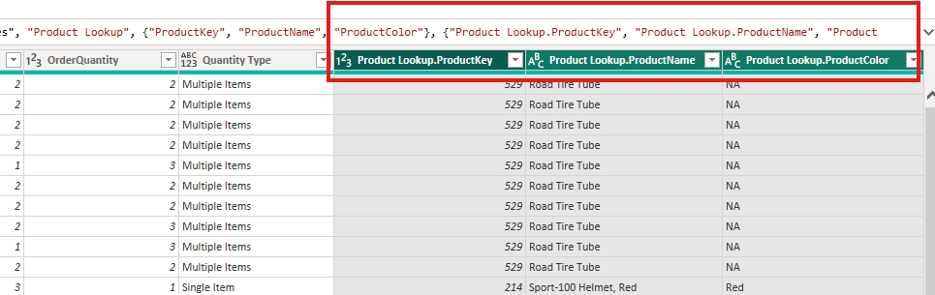

APPEND QUERIES
- Append combines tables vertically by placing the rows of one table underneath another.
- It is similar to UNION ALL in SQL, where Same type of data from different places/periods → put everything into one table.
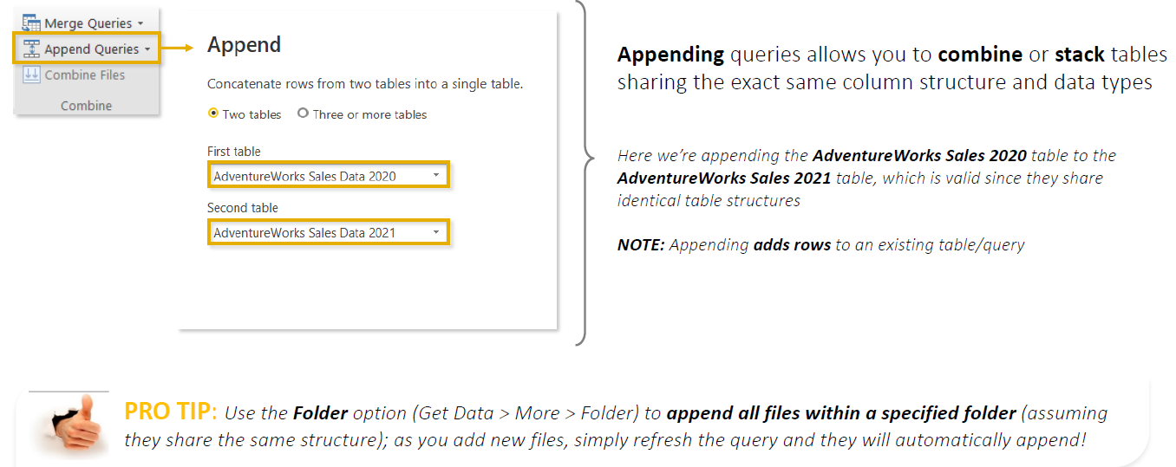
- Append Queries combines multiple tables by stacking their rows into one table.
- Append is commonly used when you have the same type of data in separate files/tables, such as:
  - Sales 2020
  - Sales 2021
  - Sales 2022
→ combined into one Sales 2020–2022 table.
- For the best results, tables should have:
  - Same column names/structure
  - Compatible data types
  - Same meaning for corresponding columns
- Go to Power Query Editor → Home → Append Queries.
- You can append:
  - Two tables
  - Three or more tables
- There are two options:
  - Append Queries → appends data into the currently selected query.
  - Append Queries as New → creates a new combined query while keeping the original queries.
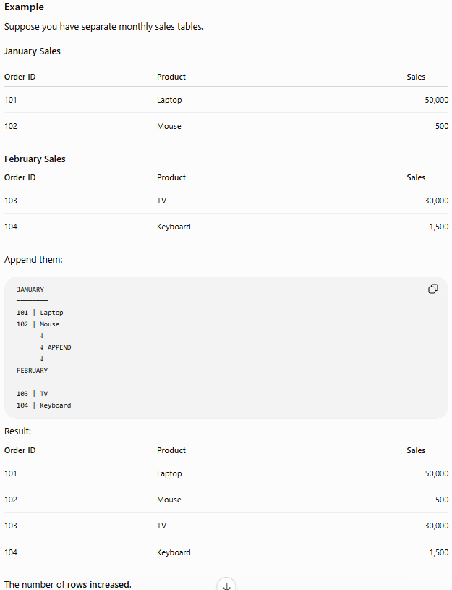
What if Append Tables Have Different Columns?
- If one table has a column that the others don't, Power Query can still append them, but the missing values will appear as null.

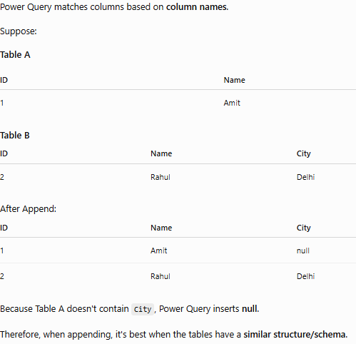
- In below example – we use Append Query As New
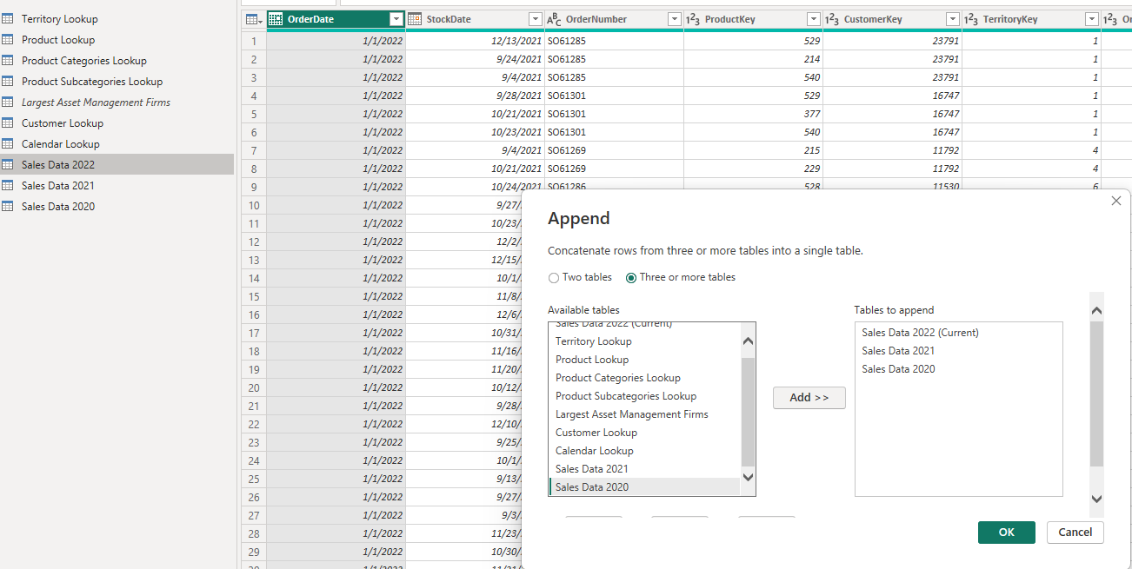

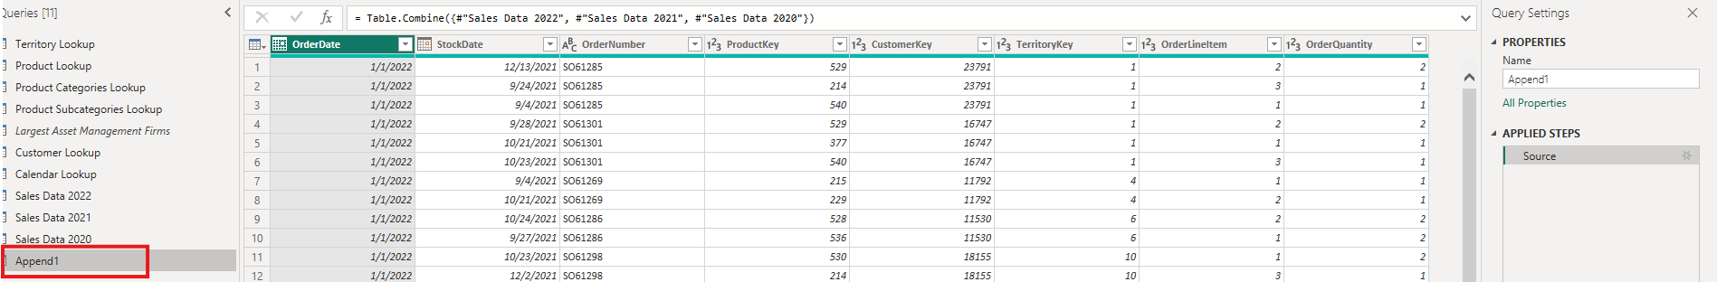
Note : With Append Queries as New, the new combined query depends on the original queries, due to this dependencies we cannot delete the source queries.
WHY CAN’T WE DELETE THE ORIGINAL TABLES AFTER APPEND?
Suppose you have:
Sales 2020 ──┐
Sales 2021 ──┼──→ Sales 2020–2022
Sales 2022 ──┘
- When you use Append Queries as New, Power Query creates a new query that references the three original queries.
- The combined Sales 2020–2022 query is therefore dependent on Sales 2020, Sales 2021, and Sales 2022.
- If you try to delete one of the original queries, Power BI warns you because the appended query needs it to produce its result.
- This means you end up maintaining 4 queries:
  - Sales 2020
  - Sales 2021
  - Sales 2022
  - Sales 2020–2022
- The Better Approach — Folder Connector
Connecting to a Folder in Power BI — Short Steps
Purpose: Combine multiple files with the same structure automatically instead of manually appending them.
- Put similar files in one folder
  - Sales 2020.csv
  - Sales 2021.csv
  - Sales 2022.csv
- In Power Query Editor, go to New Source → More → Folder.
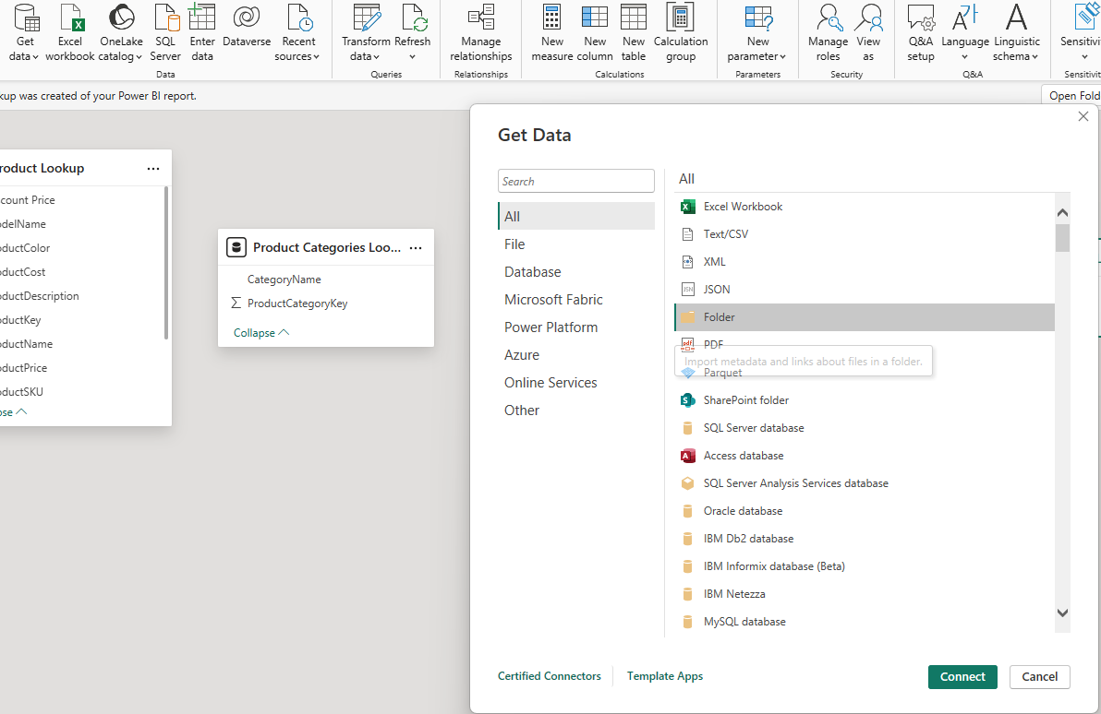
- Browse and select the folder containing the sales files.
- Power BI shows a preview of the files in the folder rather than their actual data.
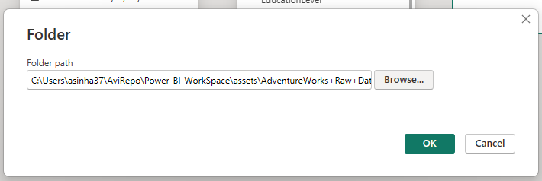
- Click Transform Data.
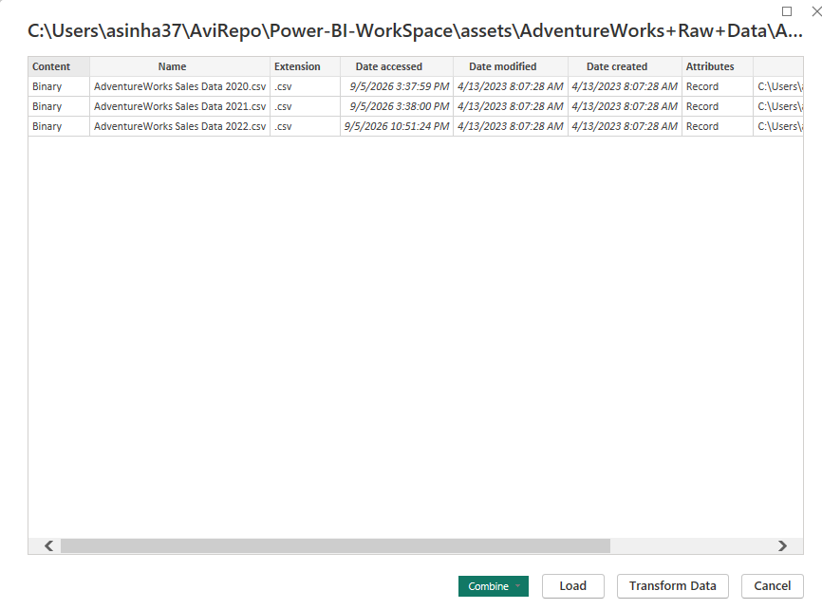
- In the Content column, click Combine Files.
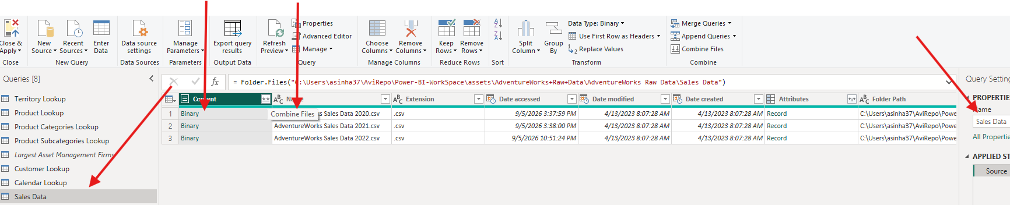
- Power BI uses a sample file to determine how the files should be combined.
  - Verify column names.
  - Verify structure/data looks correct.
- Click OK → Power BI automatically appends/stacks all files.
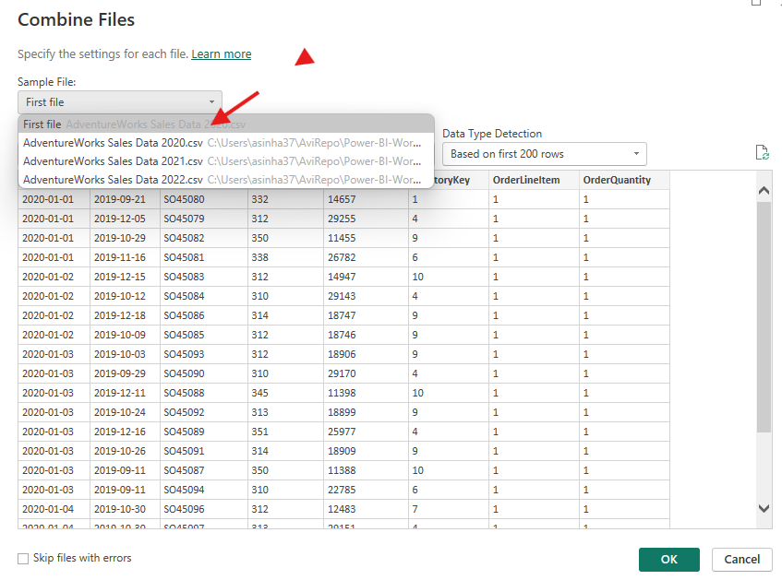
- Check the resulting combined data:
  - 2020
  - 2021
  - 2022
should now all appear in one Sales table.
- Power BI may create a Source Name column showing which file each row came from. Keep it if useful; otherwise remove it.
- Power BI automatically creates some helper queries and transformation steps behind the scenes. These can normally just be collapsed.
- Click Close & Apply to load the final combined table.
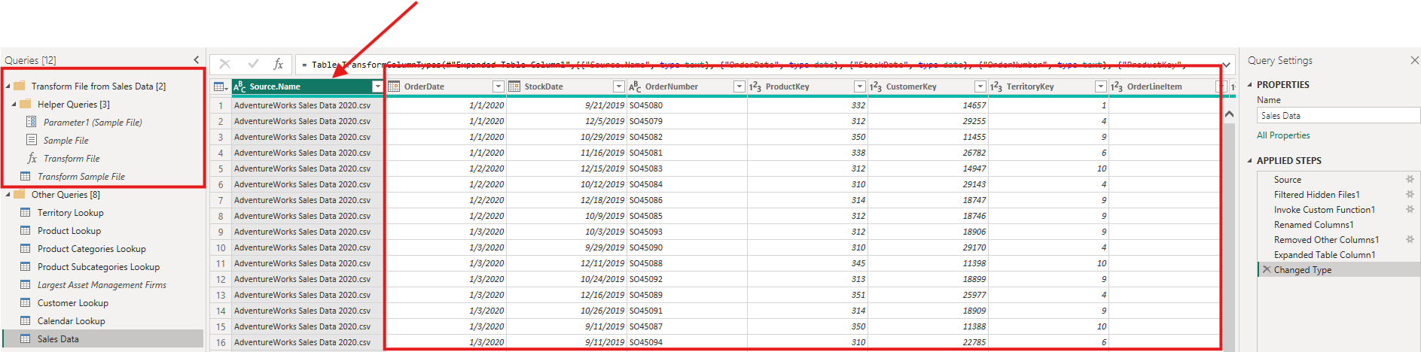
- The Main Advantage is If later you receive: Sales 2023.csv
simply place it in the same folder:
📁 Sales Data
├── Sales 2020.csv
├── Sales 2021.csv
├── Sales 2022.csv
└── Sales 2023.csv ← NEW
- Then Refresh Power BI → the new file's data is automatically included.
- Key takeaway: For recurring files with the same structure, Folder Connector + Combine Files is more scalable and easier to maintain than manually appending each file.

DATA-SOURCE SETTINGS
- When importing data files, such as CSV files, Power BI may show a data source error if the file path changes or the file is renamed.
- To fix such issues – we have multiple ways
METHOD 1
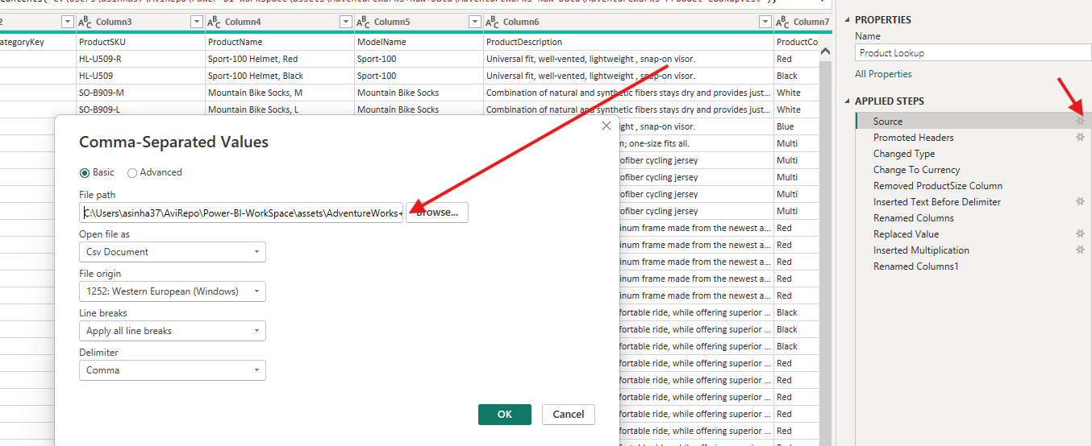
METHOD 2
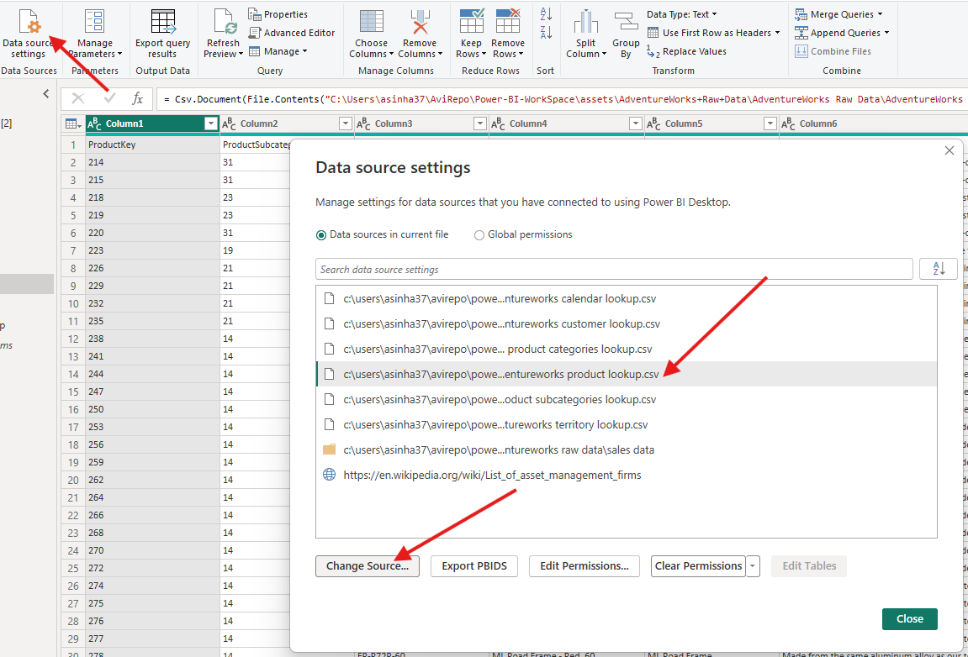

- Note: After changing the path make sure to click to “Refresh”
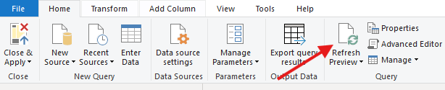

REFRESH QUERIES
- Query Refresh means asking Power BI to go back to the data source and retrieve the latest data for your queries/tables.
- For example, suppose your Power BI report uses:
  - Sales Data
  - Product Lookup
  - Customer Lookup
  - Territory Lookup
  - Calendar
- Today your Sales Data contains 100,000 transactions. Tomorrow, 5,000 new transactions are added to the source.
- When you click Home → Refresh, Power BI refreshes the relevant queries so the model can receive the latest source data.

What Happens by Default?
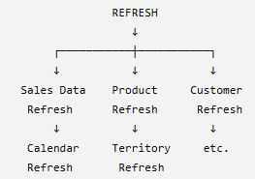 | By default, clicking Refresh in Power BI refreshes the model's included data connections/queries.  But some of these tables may rarely or never change.  For example:  - Product Lookup → static  - Territory Lookup → static  - Calendar → static  - Sales Data → changes every day  Refreshing everything unnecessarily can increase refresh time.
Controlling Which Queries Refresh
In Power Query Editor:
- Find the table/query in the Queries pane.
- Right-click the query.
- Find Include in report refresh.
- Uncheck it if the query doesn't need to refresh.
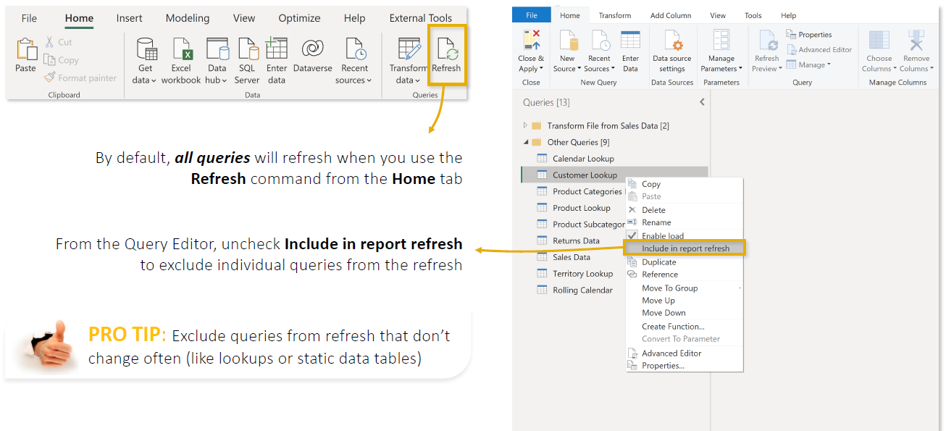
Key Points from the Lecture
- Refresh retrieves updated data from your sources.
- By default, relevant queries are generally included in report refresh.
- You can control individual queries through Power Query → Right-click query → Include in report refresh.
- If a table is static and truly doesn't need to change, you can consider excluding it from refresh.
- Frequently changing tables, such as Sales/Transactions, normally remain included.
- Reducing unnecessary refresh work can improve refresh time and efficiency.
- Enable Load and Include in Report Refresh serve different purposes.

CREATING DATA MODEL
Data modeling is the process of organizing data tables and creating relationships between them so Power BI understands how the data is connected and can analyze it correctly.
- Data modeling is mainly performed in Model View of Power BI.
- Tables are commonly organized into:
  - Fact Tables → contain transactions/numbers to analyze, e.g., Sales.
  - Dimension Tables → contain descriptive information, e.g., Product, Customer, Date.
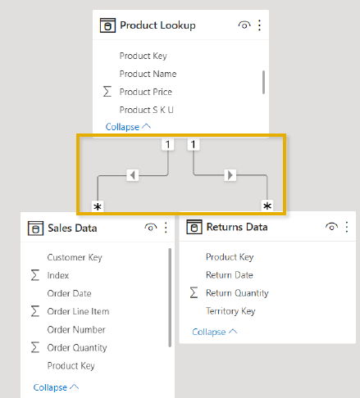 | - Tables are connected using common keys.  - Example: Sales[ProductID] ↔ Product[ProductID]  - Relationships have cardinality, such as:  - One-to-Many (1:*) — most common  - One-to-One (1:1)  - Many-to-Many (:)  - A Star Schema is generally preferred:  Dimension Tables → Fact Table ← Dimension Tables  - A good data model makes it easier to:  - Filter and analyze data correctly.  - Create DAX measures such as Total Sales and Profit.  - Build accurate reports and visuals.  - Improve model usability and performance.

NORMALIZATION
- Data normalization is the process of organizing data into separate, related tables to reduce duplicate/redundant data and improve data consistency.
- Normalization = Don't store the same information repeatedly. Separate it into logical tables and connect them using keys.
- Example
Suppose we have one large Sales table:
Order ID | Product ID | Product Name | Category | Price | Qty
101 | P01 | Laptop | Electronics | 50,000 | 1
102 | P01 | Laptop | Electronics | 50,000 | 2
103 | P01 | Laptop | Electronics | 50,000 | 1
104 | P02 | Mouse | Electronics | 500 | 3
Notice that:Laptop → Electronics → ₹50,000 is repeated again and again.This is redundant data.
After Normalization
We separate the information into two tables.
Sales Table  Order ID Product ID Qty  101 P01 1  102 P01 2  103 P01 1  104 P02 3 | Product Table  Product ID Product Name Category Price  P01 Laptop Electronics 50,000  P02 Mouse Electronics 500
Then connect them using Product ID:
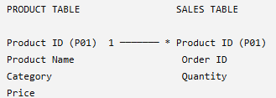
Now Laptop, Electronics, and ₹50,000 only need to be stored once in the Product table.
Key Points
- Reduces duplicate/repeated data
- Divides large tables into smaller logical tables
- Tables are connected using Primary Keys and Foreign Keys
- Improves data consistency and integrity
- Makes source/database data easier to maintain
In Power BI
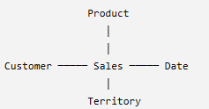  STAR SCHEMA | There's an important distinction: highly normalized designs are common in source databases, but for analytical Power BI models, we often prefer a simpler Star Schema:  - Normalization = separate data to reduce redundancy.  - Star Schema = organize analytical data into Fact and Dimension tables for easier and efficient reporting.

FACTS & DIMENSION
Let's use a simple supermarket sales example.

FACT TABLE — DATA TABLE
A Fact Table contains the transactions or events that happened in the business, along with the numerical values we want to analyze.
For example, every time a customer buys something, a transaction is recorded in the Sales fact table.
Sales Fact Table
Order ID | Date ID | Product ID | Customer ID | Quantity | Sales Amount
1001 | D01 | P01 | C01 | 2 | ₹2,000
1002 | D01 | P02 | C02 | 1 | ₹500
1003 | D02 | P01 | C03 | 3 | ₹3,000
1004 | D02 | P03 | C01 | 1 | ₹5,000
Each row represents a sales transaction.
The Fact Table contains two important types of columns:
Keys, which connect to other tables:
- Product ID
- Customer ID
- Date ID
Numeric facts, which we analyze:
- Quantity
- Sales Amount
- Cost
- Discount
- Profit
So:
Fact Table = Business transactions/events + keys + values to analyze.

DIMENSION TABLE — LOOKUP TABLE
- A Dimension Table contains descriptive information about the data in the Fact Table.
- It tells us more about the Product, Customer, Date, Location, etc.
- That's why you'll sometimes hear them called Lookup Tables.
- For example, the Sales table contains:
  - Product ID = P01
  - But what exactly is P01?
- The Product Dimension tells us.
Product Dimension
Product ID | Product Name | Category | Brand
P01 | Laptop | Electronics | Dell
P02 | Mouse | Accessories | Logitech
P03 | TV | Electronics | Samsung
Now Power BI knows:P01 → Laptop → Electronics → Dell
Customer Dimension
The Fact Table also contains Customer IDs:
Customer ID | Customer Name | City | Country
C01 | Amit | Delhi | India
C02 | Priya | Mumbai | India
C03 | Rahul | Kolkata | India
So:
C01 → Amit → Delhi → India
Date Dimension
Date ID | Date | Month | Quarter | Year
D01 | 01-Jan-26 | January | Q1 | 2026
D02 | 02-Jan-26 | January | Q1 | 2026
This lets us analyze sales by:
- Day
- Month
- Quarter
- Year

HOW FACT AND DIMENSION TABLES WORK TOGETHER?
We connect the Dimension Tables to the Fact Table using keys.
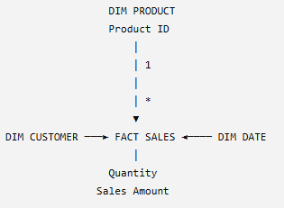 | 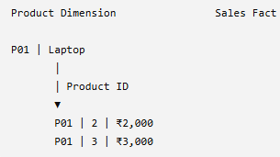

SHARED DIMENSION TABLE
- A Shared Dimension is a Dimension/Lookup table that has relationships with multiple Fact tables.
- For example:
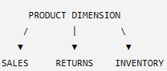
- Here, Product is a shared dimension because the same Product table can filter all three Fact tables.
Why Are Shared Dimensions Useful in Reports?
Shared dimensions allow us to analyze and compare measures from multiple Fact tables using the same field.
For example:
- Sales Fact → Sales Quantity
- Returns Fact → Return Quantity
- Inventory Fact → Stock Quantity
- Product Dimension → Product Name
Because Product is shared, we can create:
Product | Sales Qty | Return Qty | Stock Qty
Laptop | 1,000 | 50 | 200
Mobile | 800 | 30 | 150
TV | 500 | 20 | 100
- When the report filters Product = Laptop, that Product filter flows to all three Fact tables, so Power BI calculates Laptop's Sales, Returns, and Inventory together.
Other Examples
- If Date is shared between Sales and Returns: We can compare Sales vs Returns by Month.
- If Territory is shared: We can compare Sales vs Returns by Country/Region.
Key Points
- Shared Dimension = one Dimension connected to multiple Fact tables.
- It provides a common way to filter/group multiple Facts.
- It allows measures from different Fact tables to be placed together meaningfully in the same report visual.
- Fact tables generally don't need to connect directly; shared dimensions provide the common analytical path.
- A dimension can only filter Facts for which a valid relationship/filter path exists.
In simple terms: A shared dimension acts as a common filter between multiple Fact tables, allowing us to compare different business metrics—such as Sales, Returns, and Inventory—by the same Product, Date, Territory, etc.

MODEL VIEW
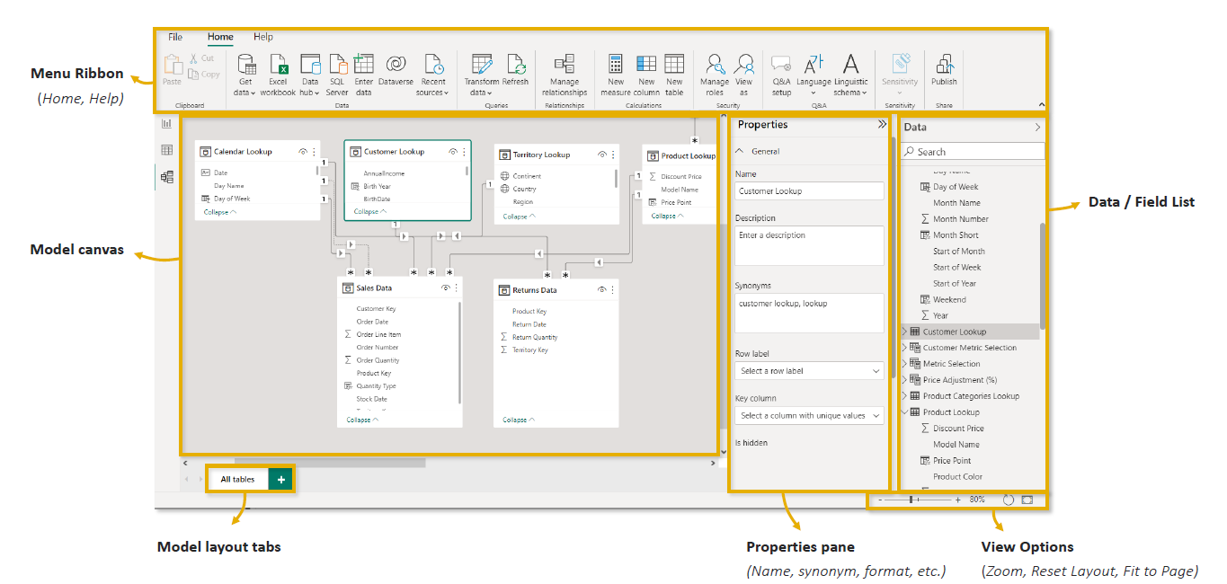

PRIMARY AND FOREIGN KEYS

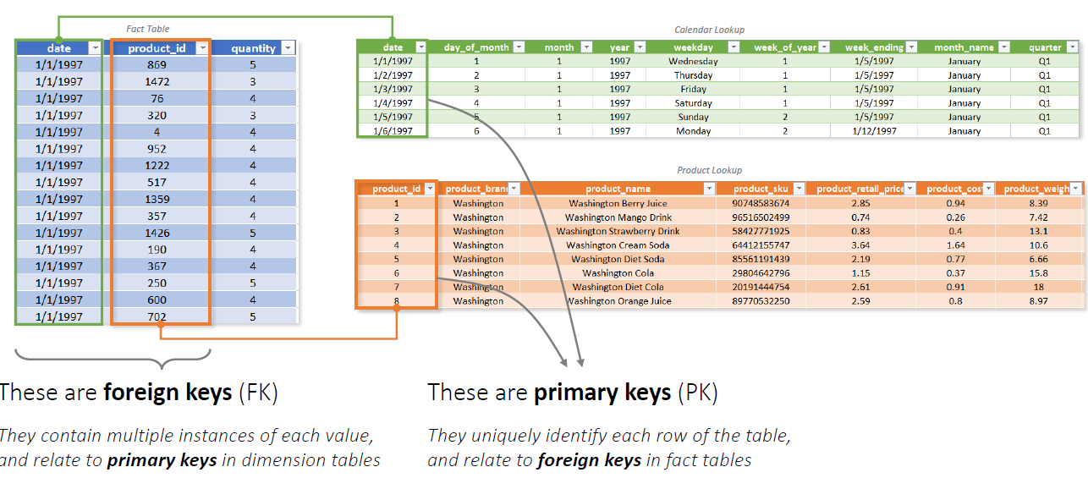
ASSIGNING PRIMARY KEY TO A COLUMN
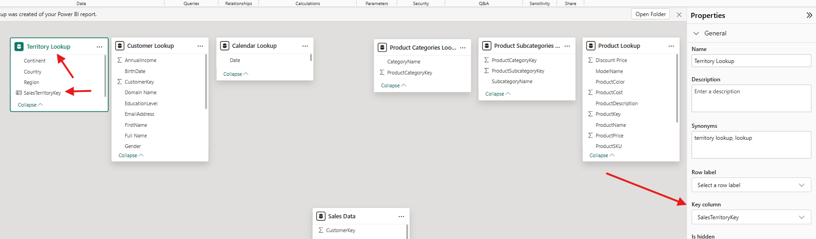

CREATING RELATIONSHIP
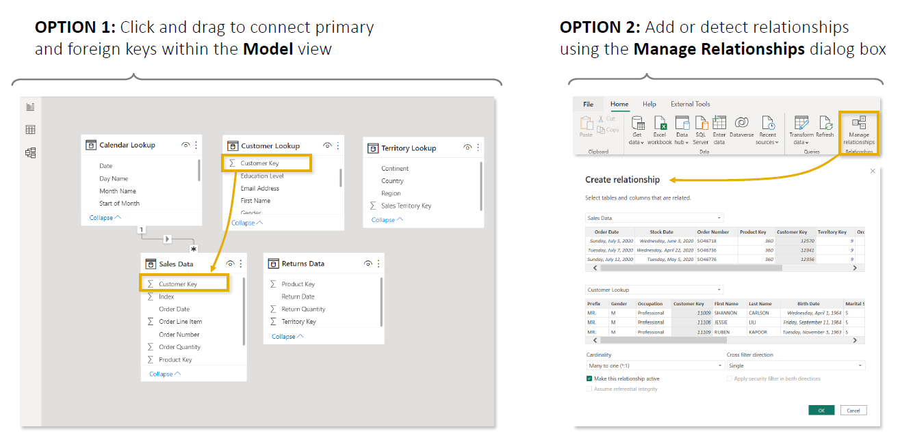

OPTION 1- DRAG AND DROP
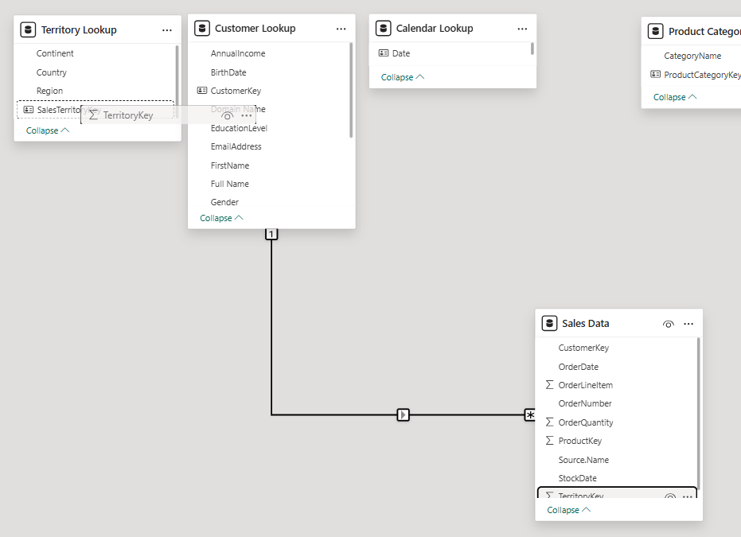

OPTION 2
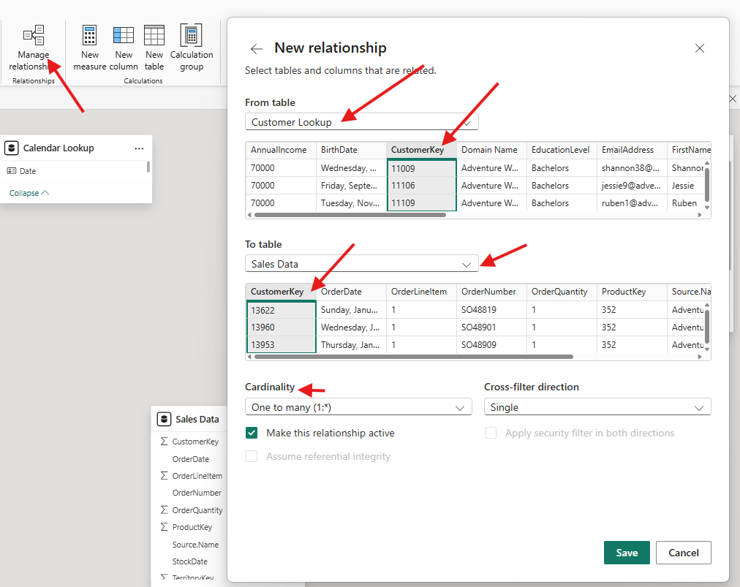
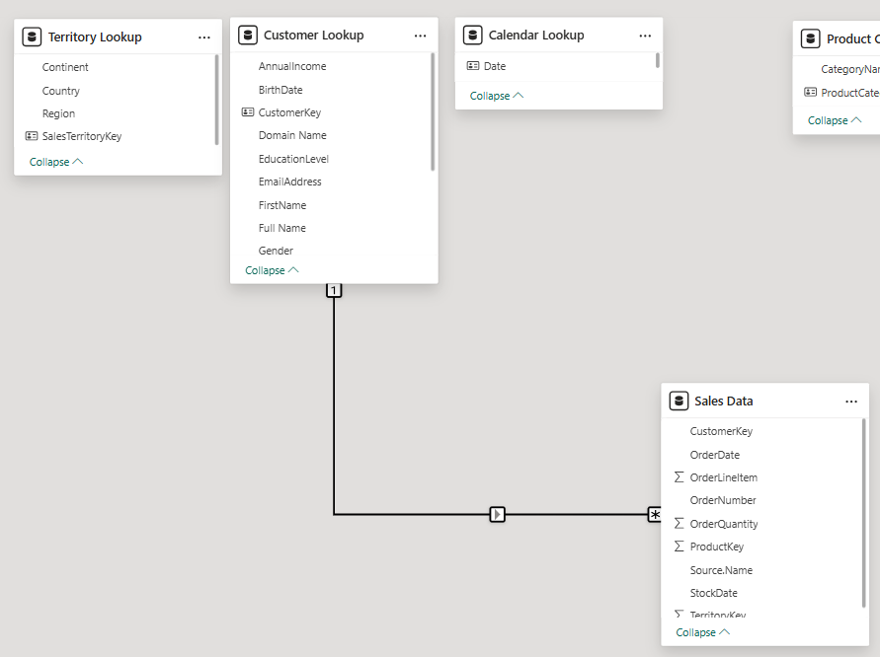

EDITING RELATIONSHIP
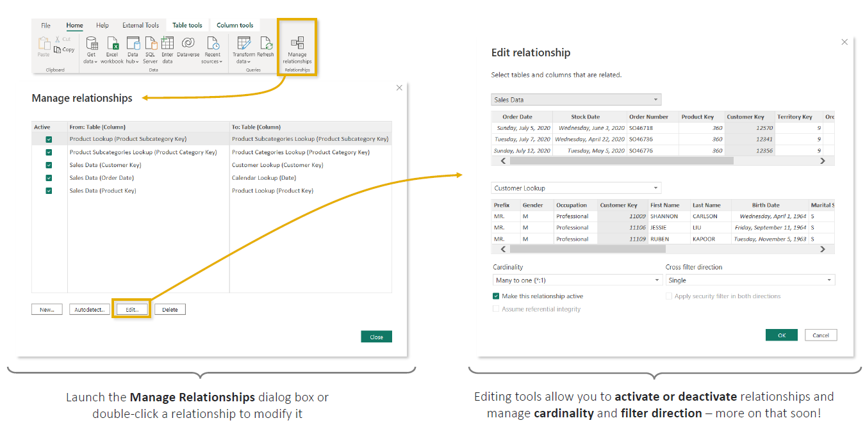

ACTIVE & INACTIVE RELATIONSHIP
- A relationship connects two tables using common columns. In Power BI, a relationship can be either Active or Inactive.
- There can be only one active relationship between tables at a time.

ACTIVE RELATIONSHIP
- An active relationship is the relationship Power BI uses automatically when filtering and calculating data.
- In Model View, it appears as a solid line.
- Example: suppose the Sales table contains two dates:
Order ID | Order Date | Ship Date | Sales
101 | 1-Jan | 3-Jan | ₹10,000
102 | 2-Jan | 5-Jan | ₹20,000
And we have a Date dimension:
Date | Month | Year
1-Jan | January | 2026
2-Jan | January | 2026
3-Jan | January | 2026
We could create two relationships:
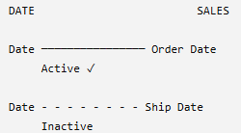
- If the relationship between Date[Date] and Sales[Order Date] is active, then when you create a report showing: Sales by Month : Power BI automatically interprets that as: “Calculate sales according to Order Date."
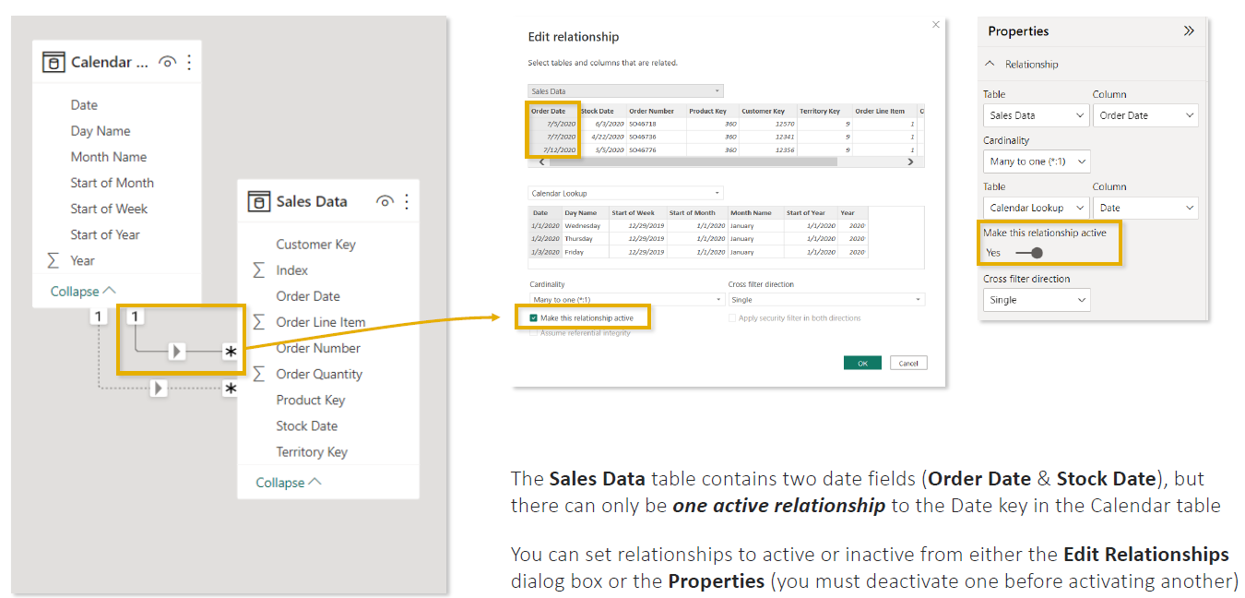

INACTIVE RELATIONSHIP
- An inactive relationship exists in the model, but Power BI does not use it automatically for normal filter propagation.
- In Model View, it appears as a dashed line.
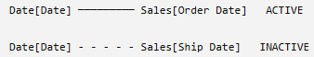
Why have an inactive relationship?
Because sometimes you need multiple relationships between the same two tables.
Here, both are logically valid:
- Date → Order Date
- Date → Ship Date
But Power BI needs an unambiguous default filtering path, so one can be active while the other remains inactive.
Key point: An inactive relationship isn't a bad or broken relationship. It's a valid relationship that Power BI doesn't use by default, but you can use it for specific calculations (in DAX Query) when needed.
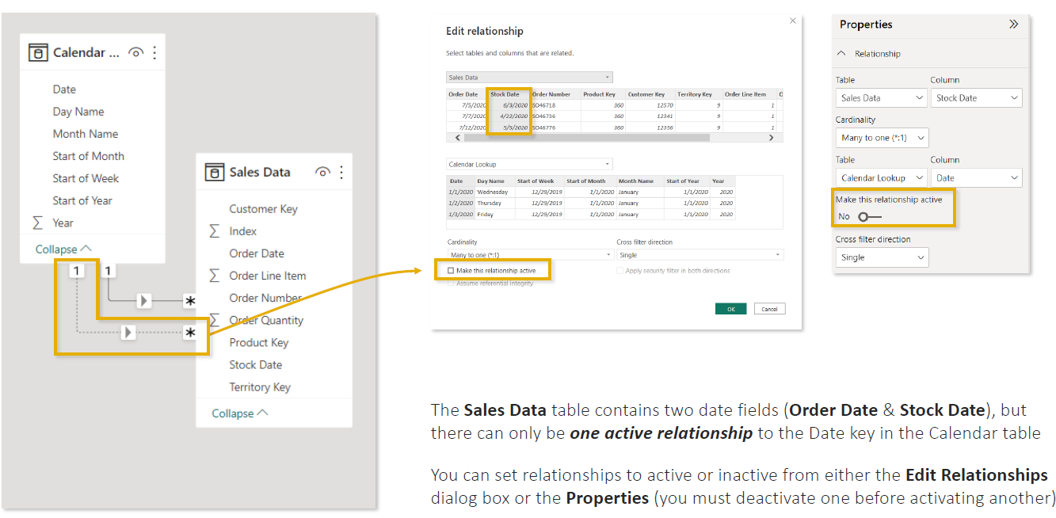

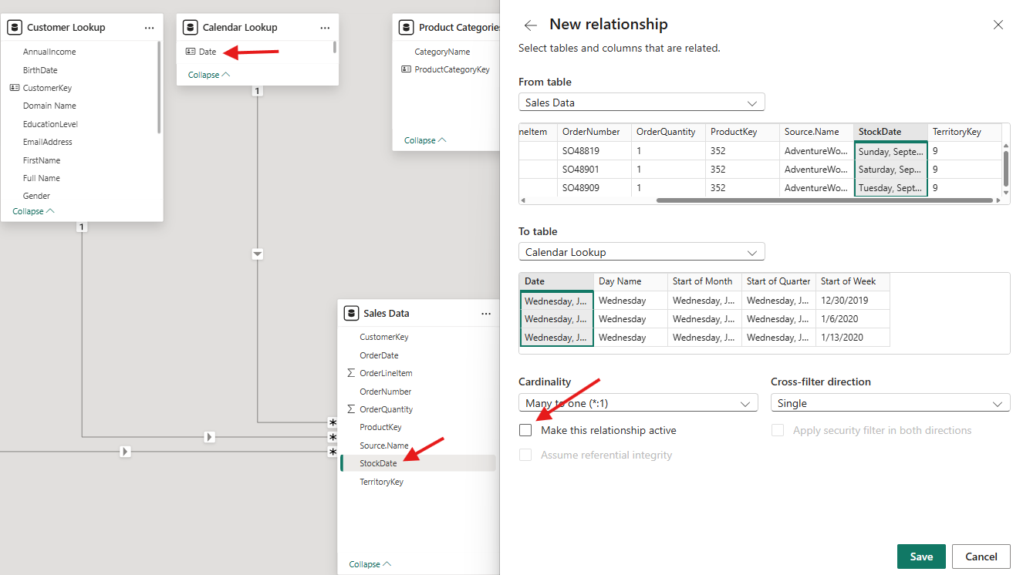

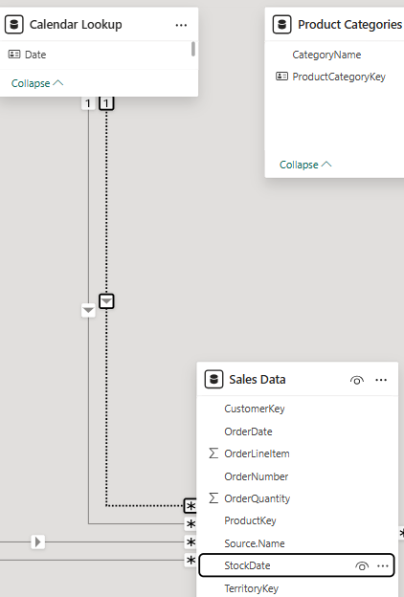
How to Change Active/Inactive
- Go to Model View.
- Select or double-click the relationship.
- Open Edit Relationship, or use the Properties pane.
- Turn Make this relationship active on/off.
- If another conflicting relationship is already active, deactivate it first.
- Activate the relationship you want Power BI to use by default.
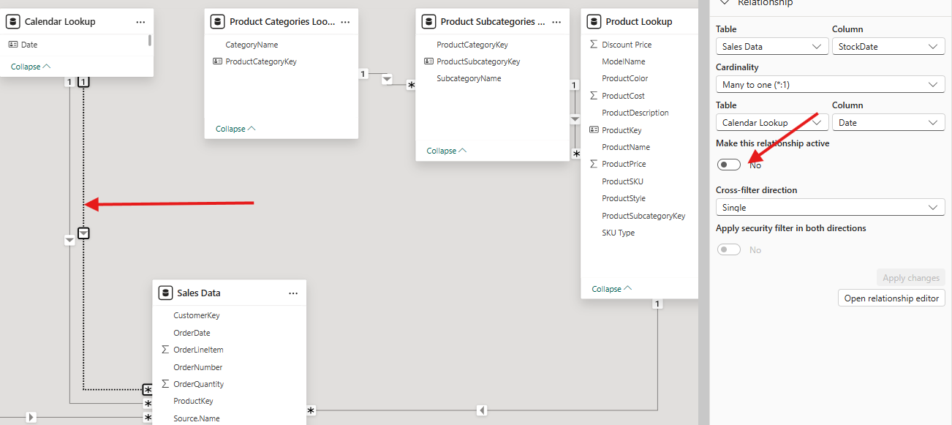
KEY POINTS
- An active relationship does not have to connect to a formally defined primary key, but in a typical 1:* relationship, the 1-side must contain unique values. Power BI uses the active relationship as the default path for filtering data.
- Power BI can have active or inactive many-to-many (*:*) relationships, where values are not unique on either side.
- However, for a standard one-to-many (1:*) relationship, the column on the 1 side must be unique; the * side can contain duplicates.

MODEL SCHEMA
A model schema is the way tables are organized and connected through relationships inside a Power BI data model.
Schema = the blueprint showing how your Fact and Dimension tables are connected.
For example, suppose you're building a retail Sales dashboard with:
- Sales
- Products
- Customers
- Dates
- Categories
- Countries
How you arrange and connect these tables determines your schema.
Two common schemas are:
- Star Schema
- Snowflake Schema
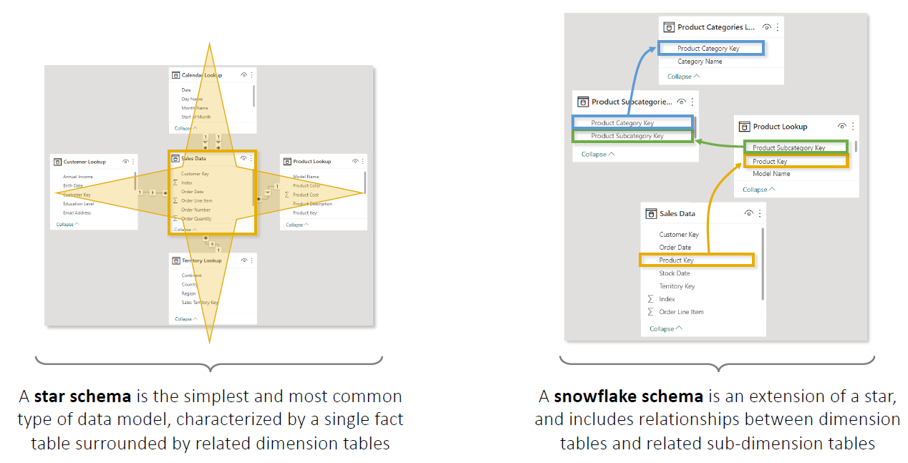

STAR SCHEMA
A Star Schema has:
- One central Fact table
- Multiple Dimension tables directly connected to the Fact table
It looks like a star, which is where the name comes from.
Example
Suppose we have a Sales Fact table:  OrderID ProductID CustomerID DateID Sales  101 P01 C01 D01 ₹50,000  102 P02 C02 D02 ₹30,000  103 P01 C03 D03 ₹20,000  And dimensions:  Product  ProductID Product Category Brand  P01 Laptop Electronics Dell  P02 Chair Furniture IKEA  Customer  CustomerID Customer City Country  C01 Amit Delhi India  C02 John London UK  Date  DateID Date Month Year  D01 1-Jan January 2026  D02 2-Jan January 2026 | 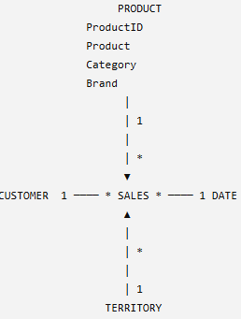

  - Note: Every Dimension directly connects to the Fact table.

SNOWFLAKE SCHEMA
- A Snowflake Schema is similar to a Star Schema, but some Dimension tables are further divided into additional related tables.
- Star → Dimensions connect directly to Fact
- Snowflake → Dimensions may connect to other Dimensions
Example
In our Star Schema, the Product table contained:  ProductID Product Category Brand  P01 Laptop Electronics Dell  P02 Mouse Accessories Logitech  - Notice In above table -Category information is inside Product.  - In a Snowflake design, we might separate Category.  Product  ProductID Product CategoryID  P01 Laptop CAT01  P02 Mouse CAT02  Category  CategoryID Category  CAT01 Electronics  CAT02 Accessories | 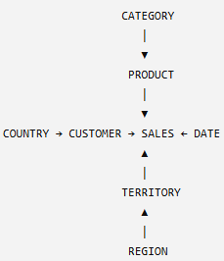

CARDINALITY
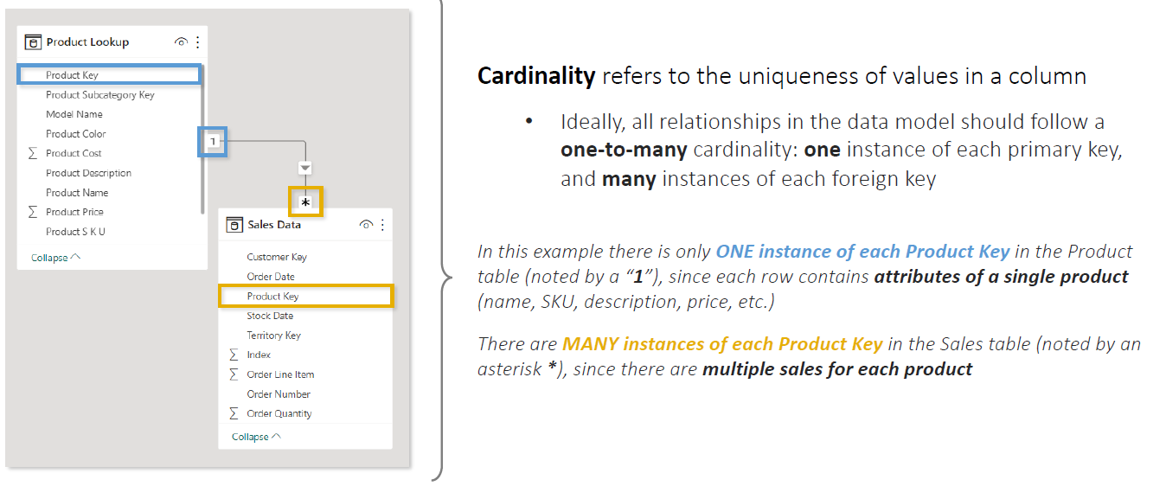

CONNECTING FACT TABLE
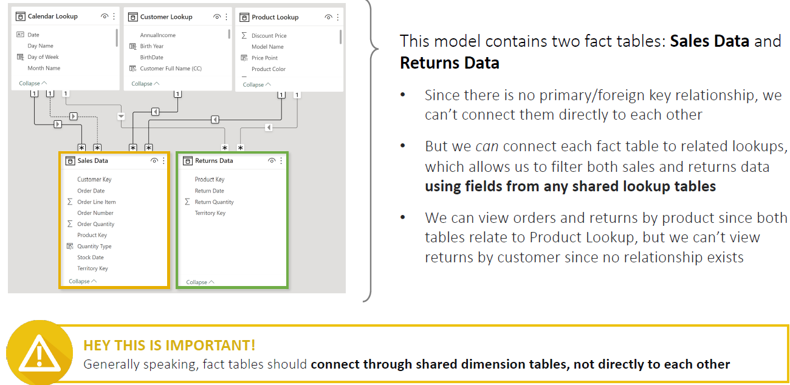
- A Power BI model can contain more than one Fact table.
- In the example:
  - Sales Data = sales transactions
  - Returns Data = product return transactions
Don't Directly Connect Fact Tables  - Sales and Returns contain repeated Product Key, Date, Territory Key, etc.  - Therefore, they should generally not be directly related to each other.  - Instead, connect both Fact tables through shared Dimension/Lookup tables. | 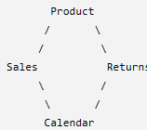
2. Connect Each Fact to Relevant Dimensions  In the example:  Returns can connect through:  - Product Key → Product Lookup  - Return Date → Calendar  - Territory Key → Territory Lookup | 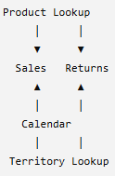
3. Shared Dimensions Can Filter Both Fact Tables  Because Product, Calendar, and Territory connect to both Sales and Returns, they can filter measures from both tables.  For example:  Analysis Possible?  Sales & Returns by Product ✅  Sales & Returns by Country ✅  Sales & Returns by Date ✅ | So you can create a report like:  Product Order Quantity Return Quantity  Bike 1,000 50  Helmet 600 20

- Key Takeaway: Multiple Fact tables should generally connect through shared Dimension tables rather than directly to each other.
- Note: A Dimension can filter a Fact table only when a valid relationship/filter path exists between them.

FILTER FLOW
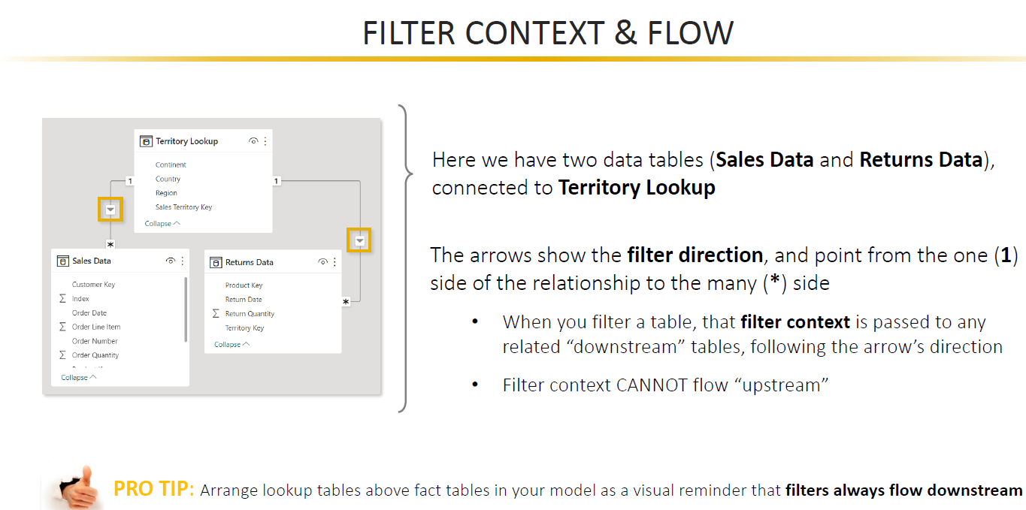
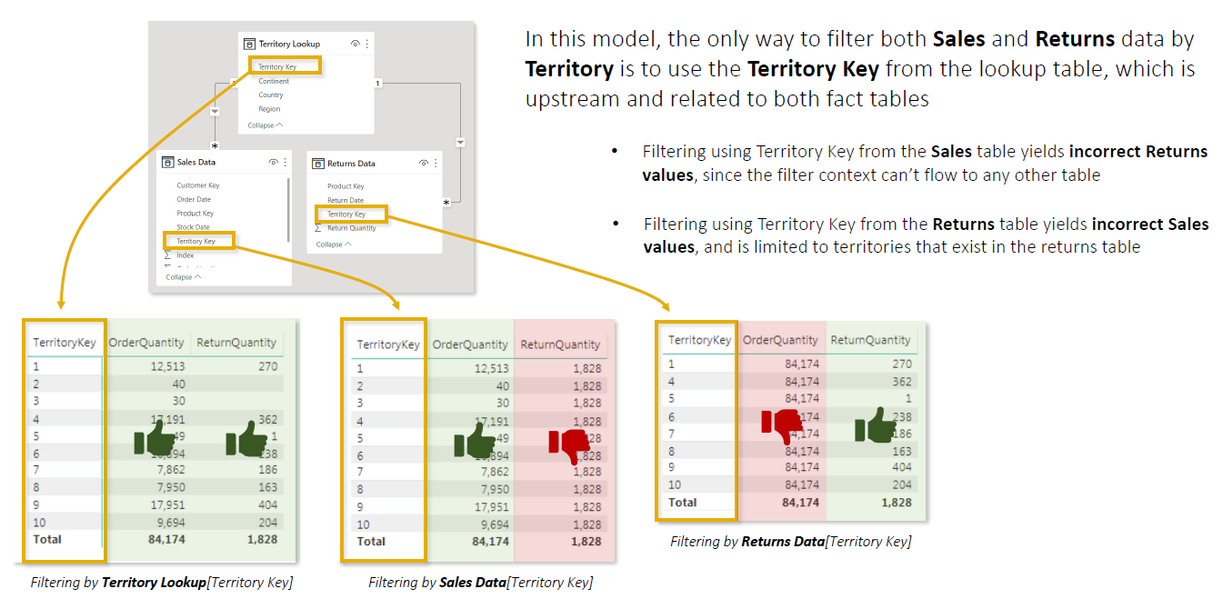
- Filter Context = Which data should be considered?
- Filter Flow = How does that filtering instruction travel through the data model?
They work together, but they are not the same thing.

FILTER CONTEXT: WHICH DATA SHOULD I CALCULATE?
Filter Context = the set of filters currently affecting a calculation.
Imagine your company has sales across:
- India
- USA
- UK
And your report has a slicer:Country = India
By selecting India, you are telling Power BI:"For the calculation I'm looking at, consider only data related to India."
That condition is part of the filter context.

Similarly, if the user selects:
- Country = India
- Year = 2026
- Product = Laptop
Power BI effectively receives the instruction:"Calculate the result only for Laptop sales in India during 2026."
That collection of filters is the filter context.
So:Filters can come from slicers, visual rows/columns, page/report filters, DAX, and other report interactions.

FILTER FLOW — "HOW DOES THAT FILTER REACH THE DATA?"
- Now Power BI has:Country = India
- But Country might be stored in a Territory Dimension, while Sales Amount is stored in the Sales Fact table.
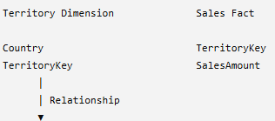
- Power BI needs a way to take: Country = India and determine which Sales rows belong to India. This is filter flow.  - Filter Flow = the path that filter context follows through relationships between tables.  THINK OF RELATIONSHIPS AS PIPES |  | 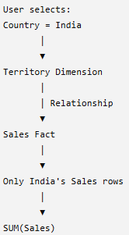
A useful analogy is water flowing through pipes.  The filter context is the water:"India"  The relationship is the pipe: Territory ─────────► Sales  The filter travels through that pipe:  - The relationship's filter direction determines which way the filter is allowed to travel. | 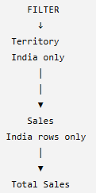
- Dimensions provide the context. Facts provide the numbers.
- For example:"What are Sales for Laptop in India during 2026?"
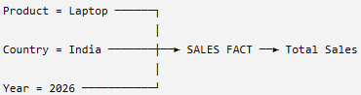
All three filters flow into Sales before the measure is calculated.

WHY DOES FILTER DIRECTION MATTER?
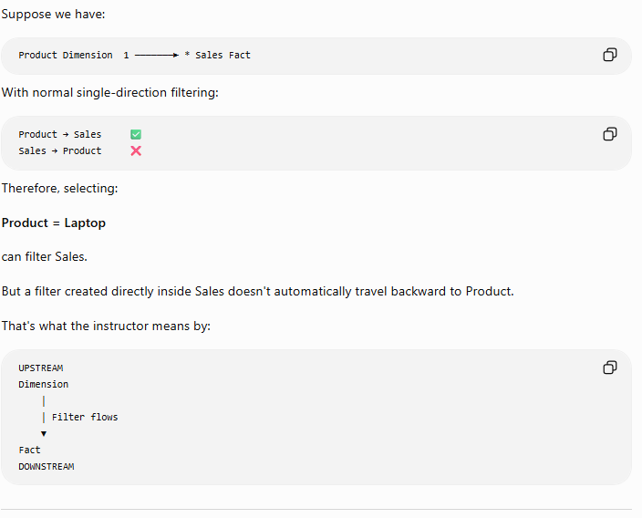
- In Star Schema, the recommended and most common setup is: Dimension (1) → Fact (*) ✅
- For example:Product Dimension (1) → Sales Fact (*)
- However, Power BI also supports bidirectional filtering, where filters can flow both ways: Dimension (1) ↔ Fact (*)
- Bidirectional relationships should be used only when needed because they can create ambiguous filter paths and make the model more complex.
Rule to remember: For most Power BI models, start with single-direction filtering from Dimension → Fact.

IN CASE OF MULTIPLE FACT TABLES
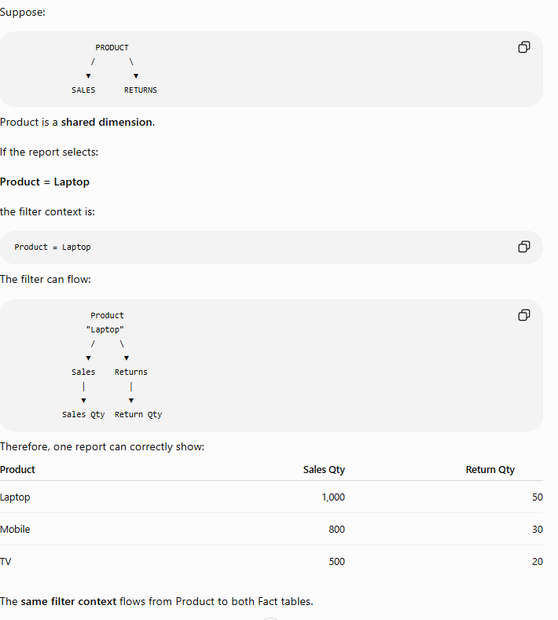

FILTER CONTEXT VS FILTER FLOW

DIMENSIONS → create FILTER CONTEXT → relationships control FILTER FLOW → FACT tables get filtered → MEASURES calculate the answer  - Filter Context = the instruction.  - Filter Flow = how the instruction travels.  - Measure = calculation performed after the instruction reaches the relevant data. | 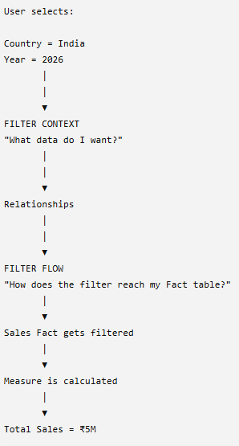

COMMON SCHEMA

HIERARCHIES

They are closely related, but not exactly the same. In everyday Power BI conversations, people sometimes use the terms interchangeably, but semantic modeling is broader than simply creating relationships between tables.
Data Modeling
Data modeling = organizing data into tables and defining how those tables are related.
For example:
Product
│
│ 1
▼ *
Customer ────► Sales ◄──── Date
▲
│
Territory
You decide:
- Which table is the Fact table
- Which are Dimension tables
- Relationships between tables
- Primary/foreign keys
- Cardinality (1:*, 1:1, *:*)
- Filter direction
- Star-schema design
So:
Data Modeling = How is my data structured and connected?

Semantic Modeling
A semantic model adds business meaning and analytical logic on top of that data structure.
It includes the data model plus things such as:
- Tables and relationships
- DAX measures
- Calculated columns
- Calculated tables
- Hierarchies
- Business-friendly names
- Formatting
- Security rules
- Other model metadata/business logic
For example, suppose you have:
Sales[SalesAmount]
Sales[Cost]
Those are just columns.
You create measures:
Total Revenue =
SUM(Sales[SalesAmount])
Total Profit =
SUM(Sales[SalesAmount]) - SUM(Sales[Cost])
Profit Margin % =
DIVIDE([Total Profit], [Total Revenue])
Now you've added business meaning to the model: Revenue, Profit, and Profit Margin are concepts that business users understand.
Think of it like this
SEMANTIC MODEL
│
┌────────────┼─────────────┐
│ │ │
Data Model Business Security/
│ Logic Metadata
│ │
Tables Measures
Relationships DAX
Star Schema Hierarchies
So a useful distinction is:
Data Model = Tables + Relationships + Structure
Semantic Model = Data Model + Business Logic + Business Meaning
In Power BI, Microsoft's current terminology generally calls the reusable analytical model behind reports a semantic model (older materials often called it a dataset).
For your learning, I'd remember it as:
Power Query → prepares the data
Data Modeling → structures/connects the data
Semantic Model → turns that structure into a business-ready analytical model
Report View → visualizes the results

CALCULATED FIELD WITH DAX

